CSS ISLAMIC STUDIES · T3QA
بِسۡمِ ٱللَّهِ ٱلرَّحۡمَٰنِ ٱلرَّحِيمِ
Topic III — The Sirah of the Prophet (PBUH) as Role Model
The Question Answers · Every past-paper question of Topic 3, 2016–2025, answered as a model
Ten model answers covering all thirteen questions — the three repeated questions are marked on the answer they share. Each begins with an answer map that states exactly what the question asks, builds its headings from the question's own words, and proves every heading from the Quran, the Sunnah and the Sirah.
Edition of September 2026 · covers the papers of 2015–2026 · written for CSS 2027 and after
Contents
HOW TO BUILD THE CONTENTS
The Contents below is left empty on purpose. In Microsoft Word, right-click anywhere on the grey line below and choose Update Field → Update entire table → OK. The full table of contents with page numbers will appear.
On a Mac: right-click (or Control-click) the line → Update Field. If you edit the notes later, repeat this step to refresh the page numbers. You can also press Ctrl + A then F9 (Windows) to update every field in the document at once.

How to Use These Answers 6
What is in this document 6
How every answer is built 6
Answer 1 · The Prophet ﷺ as Military Strategist (CSS 2016 and 2023) 7
Decoding the question 7
The model answer 8
(1) Introduction 8
(2) Characteristics before the battle 9
(3) Characteristics on the battlefield 10
(4) Characteristics in dealing with the enemy 11
(5) Characteristics of morale and ethics 11
(6) The verdict of historians 12
(7) The model for today 12
(8) Conclusion 13
Why this answer scores 13
Answer 2 · His Character in the Battlefields as Commander (CSS 2019) 14
Decoding the question 14
The model answer 14
(1) Introduction 14
(2) Courage — the bravest on the field 15
(3) Sharing every hardship with his soldiers 15
(4) Humility and consultation 15
(5) Trust in Allah with full preparation 16
(6) Integrity — keeping his word even in war 16
(7) Justice to his own soldiers 16
(8) Mercy to prisoners and the defeated 16
(9) Patience and self-control in setback 17
(10) Humility in victory 17
(11) A general estimate 17
Why this answer scores 18
Answer 3 · The Ghazwat Were Fought to Establish Peace (CSS 2024) 19
Decoding the question 19
The model answer 19
(1) Introduction 19
(2) The Quranic purpose of fighting — peace and freedom 20
(3) The causes — every Ghazwah was defensive or against a breach 21
(4) The conduct — peace inside war 22
(5) What the purpose was NOT 22
(6) The results — peace established 23
(7) Conclusion 23
Why this answer scores 24
Answer 4 · The Greatest Peace Maker: Reconciliation with Pagans, Jews and Christians (CSS 2017) 25
Decoding the question 25
The model answer 26
(1) Introduction 26
(2) The principles on which he made peace 26
(3) Reconciliation with the pagans (Mushrikin) 27
(4) Reconciliation with the Jews 28
(5) Reconciliation with the Christians 29
(6) Why he is the greatest peace maker in the world 30
(7) Conclusion 30
Why this answer scores 30
Answer 5 · A Prophet of Peace for the Contemporary Transnational World (CSS 2022 and 2018) 31
Decoding the question 31
The model answer 32
(1) Introduction 32
(2) The Prophet ﷺ as a Prophet of peace 32
(3) Peace in his own time — the proof of the model 32
(4) His model for the problems of the transnational world 33
(5) What the world has said 35
(6) Conclusion 35
Why this answer scores 35
Answer 6 · The Peace Agreements of the Prophetic Era: Contents and Parties (CSS 2025) 36
Decoding the question 36
The model answer 37
(1) Introduction 37
(2) Hilf al-Fudul — the League of the Virtuous (c. 590) 37
(3) The Pledges of Aqabah (621 and 622) 37
(4) The Charter of Madinah (1 AH / 622) 37
(5) Treaties with the tribes around Madinah (2 AH) 38
(6) The Treaty of Hudaybiyyah (6 AH / 628) 38
(7) The agreement of Khaybar and Fadak (7 AH) 39
(8) The treaties of Tabuk (9 AH) 39
(9) The treaty of Najran (9–10 AH) 39
(10) The agreement with Thaqif (9 AH) 39
(11) Summary table 39
(12) Common features of the agreements 40
(13) Conclusion 40
Why this answer scores 40
Answer 7 · Short Notes: Hudaybiyyah as a Pact of Peace; the Benefits of Khaybar (CSS 2021) 41
Decoding the question 41
The model answer 41
(a) The Treaty of Hudaybiyyah as a pact of peace 41
(b) The benefits acquired from the Battle of Khaybar 43
Why this answer scores 44
Answer 8 · The Charter of Madinah as a Social Contract (CSS 2020 and 2023) 45
Decoding the question 45
The model answer 46
(1) Introduction 46
(2) The theory of the social contract 46
(3) The 'state of nature' in Yathrib 46
(4) The provisions of the Charter 47
(5) The Charter measured against the social contract 48
(6) Where the Charter goes beyond the Western social contract 48
(7) Modern comparison and relevance 49
(8) Conclusion 49
Why this answer scores 50
Answer 9 · The Status and Grade of Tolerance and Forgiveness in the Life of the Prophet ﷺ (CSS 2020) 51
Decoding the question 51
The model answer 51
(1) Introduction 51
(2) The status of tolerance and forgiveness 52
(3) The grades of tolerance and forgiveness 53
(4) The highest grade in the great tests 54
(5) Tolerance in daily life 55
(6) Religious tolerance 55
(7) The limit — forgiveness is not weakness 56
(8) Conclusion 56
Why this answer scores 56
Answer 10 · Makarim al-Akhlaq and Social Peace; How the Prophet ﷺ Completed the Morals (CSS 2025) 57
Decoding the question 57
The model answer 57
(1) Introduction 57
(2) Why social peace needs morals, not law alone 58
(3) The importance of noble morals in establishing social peace 58
(4) How the Messenger of Allah ﷺ completed the morals 60
(5) Conclusion and Pakistan 62
Why this answer scores 62

How to Use These Answers

What is in this document
# | Paper | Question (short) | Answer
1 | 2016 Q4 · 2023 Q3 | Characteristics of a military strategist / the Prophet ﷺ as a model for military strategy | Answer 1
2 | 2019 Q3 | His character in the battlefields as commander | Answer 2
3 | 2024 Q3 | The purpose of the Ghazwat was to establish peace | Answer 3
4 | 2017 Q5 | Greatest peace maker: reconciliation with pagans, Jews and Christians | Answer 4
5 | 2022 Q6 · 2018 Q8 | Prophet of peace for the contemporary transnational world / of peace and safety | Answer 5
6 | 2025 Q6 | Contents and parties of the peace agreements of his era | Answer 6
7 | 2021 Q8 | Notes: Hudaybiyyah as a pact of peace; benefits of Khaybar | Answer 7
8 | 2020 Q6 · 2023 Q6 | The Charter of Madinah as a social contract | Answer 8
9 | 2020 Q2 | Status and grade of tolerance and forgiveness in his life | Answer 9
10 | 2025 Q2 | Makarim al-Akhlaq and social peace; how he completed the morals | Answer 10

Three questions were set twice in nearly the same words. Each pair shares one answer, and a 'same question, other year' box shows what to change for the second wording.

How every answer is built
1. The question, exactly as set.
2. The answer map — the centre states exactly what the question asks, limb by limb; every box is a heading of the answer, and every point is a complete idea (the verse or hadith and its point, not only its source).
3. Decoding the question — the command words and what each limb demands.
4. The model answer — headings from the question's own words; the evidence in each point in the order Quran → Hadith → Sirah → scholars; figures; the Pakistan or modern angle; a conclusion with a verse or hadith.
5. Why this answer scores.
TRAP · USE THE ANSWERS AS MODELS, NOT SCRIPTS
Learn the structure and the evidence; build your headings from the words of the question you are given. A model answer is fuller than you can write in 33 minutes — choose the headings and evidence you can reproduce well.

Answer 1 · The Prophet ﷺ as Military Strategist (CSS 2016 and 2023)
THE QUESTION · CSS 2016 · Q4 · 20 marks
Describe the characteristics of Military strategist in the light of Sirah of Muhammad (PBUH) with arguments.

SAME QUESTION, OTHER YEAR · CSS 2023 · Q3
'Discuss the Holy Prophet's (ﷺ) Role as a Model for Military Strategy.' Use this answer, but give heading (4) the title 'The model for today' and expand it: each principle → its modern military form (deterrence, intelligence, joint command, civil–military ethics).

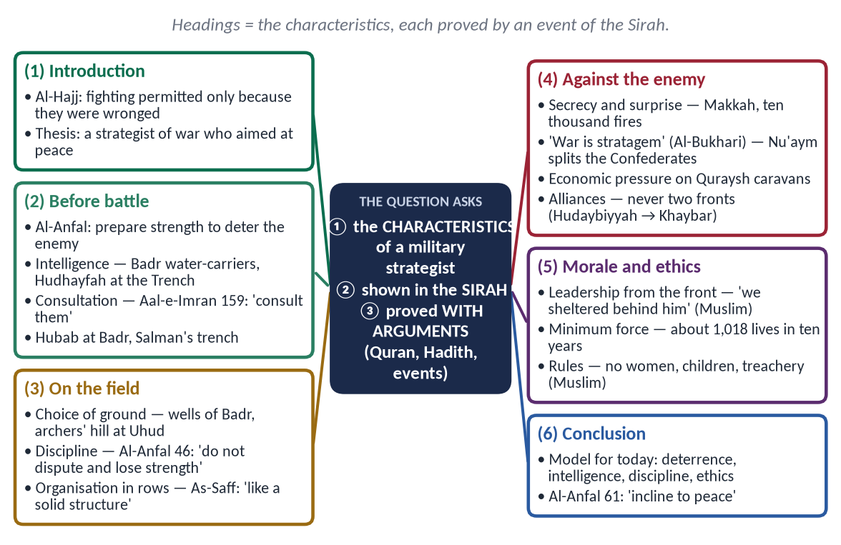
Figure 1 · The answer map: every branch is one numbered heading of the model answer below.

Decoding the question
- 'Characteristics of a military strategist' = the qualities and principles of strategy — not a list of battles.
- 'In the light of Sirah' = every characteristic must be shown by an event.
- 'With arguments' = Quran, Hadith and the judgement of historians.
- Organise by stage of war — before, during, against the enemy, ethics — so the answer reads like a strategy manual.

The model answer

(1) Introduction
✦ QURAN
﴿أُذِنَ لِلَّذِينَ يُقَٰتَلُونَ بِأَنَّهُمۡ ظُلِمُواْۚ وَإِنَّ ٱللَّهَ عَلَىٰ نَصۡرِهِمۡ لَقَدِيرٌ﴾
“Permission [to fight] has been given to those who are being fought, because they were wronged. And indeed, Allah is competent to give them victory.” (Al-Hajj, Quran)
➜ Permission to fight was given because they had been wronged — the Prophet ﷺ became a military leader only when war was forced on the Muslims.

For thirteen years in Makkah the Prophet ﷺ did not fight back. In Madinah he became head of a state surrounded by enemies, and in ten years he turned a small community of refugees into the ruling power of Arabia — with about 1,018 lives lost on both sides in all his battles. That result is the proof of a strategist of the highest order. His characteristics fall into four groups: preparation before battle, conduct on the field, dealing with the enemy, and morale and ethics.
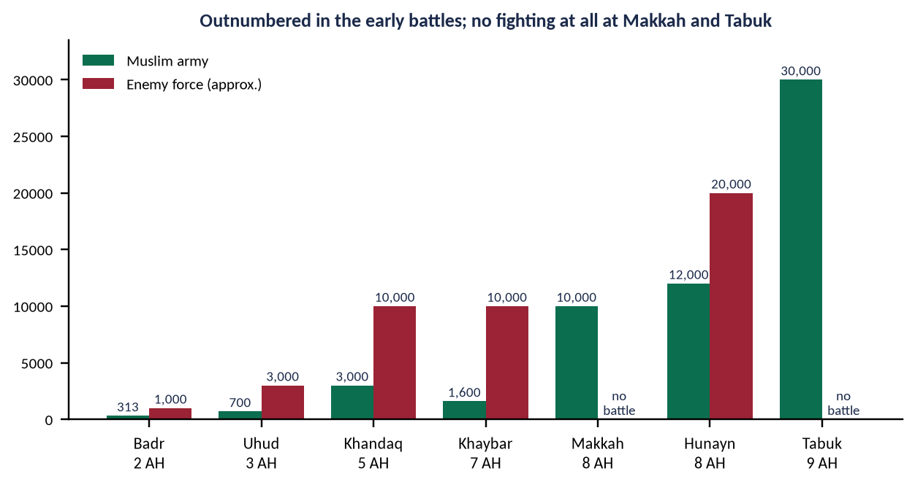
Figure 2 · The size of the forces in the major Ghazwat — outnumbered at first, unopposed at the end.

(2) Characteristics before the battle

(i) Preparation and deterrence
✦ QURAN
﴿وَأَعِدُّواْ لَهُم مَّا ٱسۡتَطَعۡتُم مِّن قُوَّةٖ وَمِن رِّبَاطِ ٱلۡخَيۡلِ تُرۡهِبُونَ بِهِۦ عَدُوَّ ٱللَّهِ وَعَدُوَّكُمۡ …﴾
“Prepare against them whatever you are able of power and of steeds of war, by which you may deter the enemy of Allah and your enemy.” (Al-Anfal, Quran)
➜ Prepare whatever strength you can — to deter the enemy, so that war may be avoided.

✦ HADITH
أَلَا إِنَّ الْقُوَّةَ الرَّمْيُ
“Indeed, strength is in shooting.” (Muslim)
➜ He ordered training in archery and horsemanship.

(ii) Intelligence
Before Badr he asked two Quraysh water-carriers how many camels were slaughtered daily — 'nine or ten' — and judged the army at 900 to 1,000 (Ibn Hisham). At the Trench he sent Hudhayfah (RA) into the enemy camp at night.

(iii) Consultation
✦ QURAN
﴿فَبِمَا رَحۡمَةٖ مِّنَ ٱللَّهِ لِنتَ لَهُمۡۖ وَلَوۡ كُنتَ فَظًّا غَلِيظَ ٱلۡقَلۡبِ لَٱنفَضُّواْ مِنۡ حَوۡلِكَۖ …﴾
“So by mercy from Allah you were gentle with them; had you been harsh and hard-hearted, they would have scattered from around you.” (Aal-e-Imran, Quran)
➜ 'Consult them in the matter, and when you have decided, rely upon Allah.'

- Badr: Hubab ibn al-Mundhir (RA) asked whether the position was revelation or tactics, and proposed holding the last well; the Prophet ﷺ agreed at once.
- Uhud: he accepted the majority view to meet the enemy outside the city.
- The Trench: he adopted Salman al-Farisi's (RA) Persian idea.

(iv) Alliances and treaties
Treaties with Banu Damrah, Juhaynah and Khuza'ah secured the routes around Madinah. Hudaybiyyah (6 AH) neutralised the Quraysh so that Khaybar (7 AH) could be dealt with — he never fought on two fronts at once.

(3) Characteristics on the battlefield

(i) Choice of ground
At Badr he held the wells, leaving the enemy thirsty. At Uhud he put the mountain behind him and fifty archers on the hill under Abdullah ibn Jubayr (RA): 'Do not leave your place even if you see birds snatching us' (Al-Bukhari).

(ii) Discipline and obedience
✦ QURAN
﴿وَأَطِيعُواْ ٱللَّهَ وَرَسُولَهُۥ وَلَا تَنَٰزَعُواْ فَتَفۡشَلُواْ وَتَذۡهَبَ رِيحُكُمۡۖ وَٱصۡبِرُوٓاْۚ إِنَّ ٱللَّهَ مَعَ ٱلصَّـٰبِرِينَ﴾
“And obey Allah and His Messenger, and do not dispute and [thus] lose courage and [then] your strength would depart; and be patient. Indeed, Allah is with the patient.” (Al-Anfal, Quran)
➜ Obey, and do not dispute, or you will lose courage and your strength will depart.

✦ QURAN
﴿… حَتَّىٰٓ إِذَا فَشِلۡتُمۡ وَتَنَٰزَعۡتُمۡ فِي ٱلۡأَمۡرِ وَعَصَيۡتُم مِّنۢ بَعۡدِ مَآ أَرَىٰكُم مَّا تُحِبُّونَۚ …﴾
“…until you lost courage, disputed about the order and disobeyed, after He had shown you what you love.” (Aal-e-Imran, Quran)
➜ At Uhud victory became loss when the archers disputed and disobeyed — the lesson is written in the Quran.

(iii) Organisation in rows
✦ QURAN
﴿إِنَّ ٱللَّهَ يُحِبُّ ٱلَّذِينَ يُقَٰتِلُونَ فِي سَبِيلِهِۦ صَفّٗا كَأَنَّهُم بُنۡيَٰنٞ مَّرۡصُوصٞ﴾
“Indeed, Allah loves those who fight in His cause in a row as though they are a [single] structure joined firmly.” (As-Saf, Quran)
➜ Allah loves those who fight in His cause in rows, like a solid structure.

At Badr he straightened the rows with an arrow — a disciplined line in a land of tribal charge-and-retreat.

(iv) Innovation — the Trench
A trench of about 5,000 cubits, dug in six days, stopped 10,000 Confederates; Arab cavalry had never faced one.

(v) Leadership from the front
✦ HADITH
كُنَّا إِذَا احْمَرَّ الْبَأْسُ نَتَّقِي بِهِ
“When the fighting grew fierce, we took shelter behind him.” (Muslim)
➜ The commander stood nearest to the enemy.

(4) Characteristics in dealing with the enemy

(i) Secrecy and surprise
He concealed the march on Makkah, prayed 'O Allah, blind their eyes', and ordered ten thousand fires at night; Abu Sufyan saw them and knew resistance was hopeless — Makkah fell almost without a battle.

(ii) Stratagem and dividing the enemy
✦ HADITH
الْحَرْبُ خَدْعَةٌ
“War is stratagem.” (Al-Bukhari and Muslim)
➜ At the Trench Nu'aym ibn Mas'ud (RA) sowed mistrust between Quraysh and Banu Qurayzah; the alliance broke.

(iii) Economic pressure
Patrols against the Quraysh caravans to Syria struck the Makkan economy — the source of their war-power.

(iv) Speed and pursuit
The day after Uhud he marched to Hamra al-Asad with the wounded; the Quraysh, believing the Muslims unbroken, went home.

(5) Characteristics of morale and ethics

(i) Morale through faith
✦ QURAN
﴿وَلَا تَهِنُواْ وَلَا تَحۡزَنُواْ وَأَنتُمُ ٱلۡأَعۡلَوۡنَ إِن كُنتُم مُّؤۡمِنِينَ﴾
“So do not weaken and do not grieve, and you will be superior if you are [true] believers.” (Aal-e-Imran, Quran)
➜ 'Do not weaken and do not grieve; you will be superior if you are believers' — revealed after Uhud.

(ii) Ethics of war
✦ HADITH
وَلَا تَغُلُّوا، وَلَا تَغْدِرُوا، وَلَا تَمْثُلُوا، وَلَا تَقْتُلُوا وَلِيدًا
“Do not steal from the spoils, do not betray, do not mutilate, and do not kill a child.” (Muslim)
➜ His standing orders to every commander.

(iii) Minimum force
About 259 Muslims and 759 enemies died in all his battles — about 1,018 in ten years (Qazi Sulaiman Mansurpuri) — while bringing about a million square miles under peace.
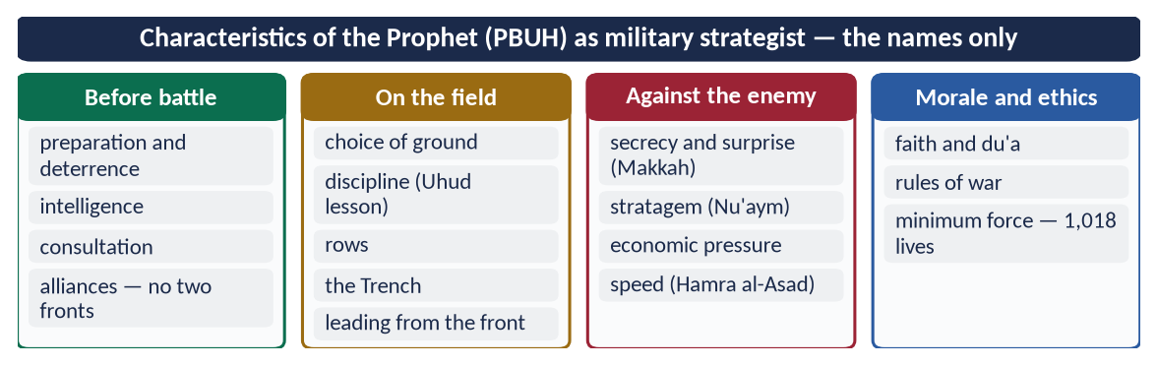
Figure 3 · At a glance — characteristics of the Prophet ﷺ as military strategist — the names only. The detail is in the sections above.

(6) The verdict of historians
✦ SCHOLARLY VIEW
Dr Muhammad Hamidullah · The Battlefields of the Prophet Muhammad
After surveying Badr, Uhud and the Trench on the ground, Hamidullah showed that each position and movement was a deliberate choice fitted to terrain, numbers and supply.
➜ His strategy was planned, not accidental.

✦ SCHOLARLY VIEW
Sir John Bagot Glubb (Glubb Pasha) · The Life and Times of Muhammad
A British general with long command of Arab soldiers, Glubb judged that the Prophet's ﷺ success came from his grasp of politics and morale, not tactics alone.
➜ War joined to policy — the mark of a true strategist.

(7) The model for today
- Deterrence (Al-Anfal 60) — the basis of Pakistan's defence doctrine of credible minimum deterrence.
- Intelligence and consultation — joint staff and professional advice before decisions.
- Discipline — the lesson of Uhud for every army.
- Ethics — the Prophetic rules anticipate the Geneva Conventions.

(8) Conclusion
✦ QURAN
﴿وَإِن جَنَحُواْ لِلسَّلۡمِ فَٱجۡنَحۡ لَهَا وَتَوَكَّلۡ عَلَى ٱللَّهِۚ إِنَّهُۥ هُوَ ٱلسَّمِيعُ ٱلۡعَلِيمُ﴾
“And if they incline to peace, then incline to it [also] and rely upon Allah. Indeed, it is He who is the Hearing, the Knowing.” (Al-Anfal, Quran)
➜ 'If they incline to peace, incline to it as well.'

The Prophet ﷺ was a strategist who prepared for war in order to make war unnecessary. He won by preparation, intelligence, consultation, discipline and surprise, and he fought by rules that protected the innocent. His campaigns ended not in empire for its own sake but in a peaceful Arabia — the final proof that his strategy was the servant of his mission of mercy.

Why this answer scores
- Headings are characteristics, grouped by the stages of war — exactly what 'characteristics of a strategist' asks.
- Every characteristic has an event and a text — 'with arguments'.
- Numbers (313, 1,000, 50 archers, 1,018) and a figure show command of detail; the modern model covers the 2023 wording.

Answer 2 · His Character in the Battlefields as Commander (CSS 2019)
THE QUESTION · CSS 2019 · Q3 · 20 marks
Give a general estimate of Holy Prophet's (PBUH) character in the battle fields as commander.

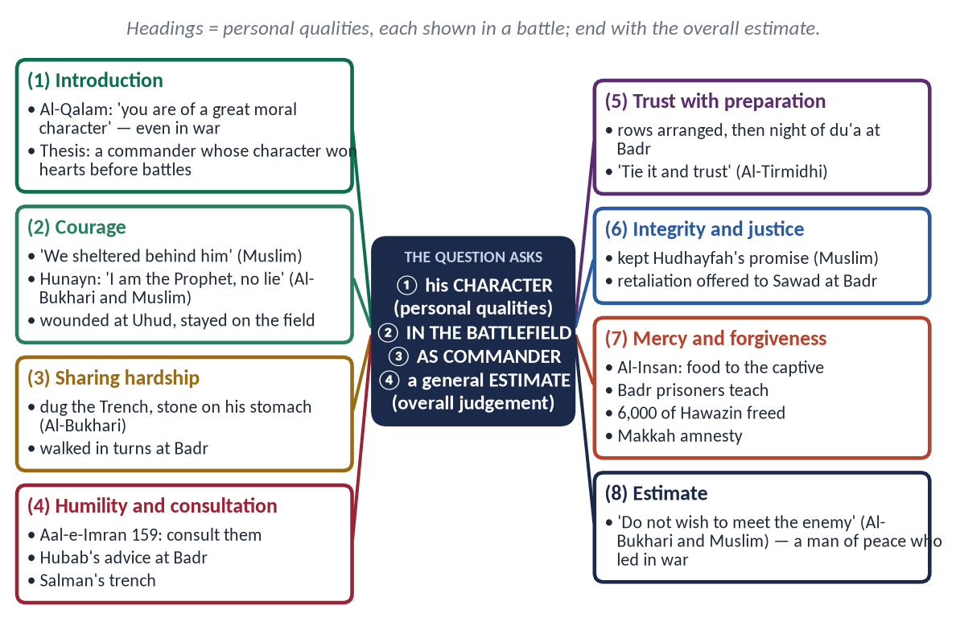
Figure 4 · The answer map: every branch is one numbered heading of the model answer below.

Decoding the question
- 'Character' = personal and moral qualities, not tactics — this is the difference from 2016.
- 'In the battlefields' = show each quality in a real battle.
- 'General estimate' = end with an overall judgement — what kind of commander he was.

The model answer

(1) Introduction
✦ QURAN
﴿وَإِنَّكَ لَعَلَىٰ خُلُقٍ عَظِيمٖ﴾
“And indeed, you are of a great moral character.” (Al-Qalam, Quran)
➜ 'Indeed, you are of a great moral character' — a character that did not change in the heat of battle.

In war, most leaders show a different face: hard, proud, revengeful. The Prophet ﷺ led about 27 expeditions and fought in about nine battles, yet his character remained the same — brave, humble, just and merciful. His men followed him not from fear but from love. That is the key to his success as a commander.

(2) Courage — the bravest on the field
✦ HADITH
كُنَّا إِذَا احْمَرَّ الْبَأْسُ نَتَّقِي بِهِ
“When the fighting grew fierce, we took shelter behind him.” (Muslim)
➜ Al-Bara' (RA) — the bravest was the one closest to the enemy.

At Hunayn, when an ambush broke the army, he rode his mule towards the enemy, calling:
✦ HADITH
أَنَا النَّبِيُّ لَا كَذِبْ، أَنَا ابْنُ عَبْدِ الْمُطَّلِبْ
“I am the Prophet, no lie; I am the son of Abd al-Muttalib.” (Al-Bukhari and Muslim)
➜ He named himself to the enemy; the army regrouped around him.

At Uhud his tooth was broken and his helmet driven into his face, but he stayed on the field.

(3) Sharing every hardship with his soldiers
At the Trench he dug and carried earth until dust covered his body; Jabir (RA) saw him with a stone tied to his stomach from hunger, like the others (Al-Bukhari). At Badr three men shared one camel; he walked his turn and refused to be spared.

(4) Humility and consultation
✦ QURAN
﴿فَبِمَا رَحۡمَةٖ مِّنَ ٱللَّهِ لِنتَ لَهُمۡۖ وَلَوۡ كُنتَ فَظًّا غَلِيظَ ٱلۡقَلۡبِ لَٱنفَضُّواْ مِنۡ حَوۡلِكَۖ …﴾
“So by mercy from Allah you were gentle with them; had you been harsh and hard-hearted, they would have scattered from around you.” (Aal-e-Imran, Quran)
➜ 'Consult them in the matter' — the command came even after Uhud, when their disobedience had cost the battle.

He accepted the advice of a young Companion, Hubab, at Badr and of a Persian, Salman, at the Trench. At Uhud he followed the majority against his own view.

(5) Trust in Allah with full preparation
✦ HADITH
اعْقِلْهَا وَتَوَكَّلْ
“Tie it, and then trust in Allah.” (Al-Tirmidhi)
➜ Means first, then trust.

At Badr he arranged the rows with his own hand, then spent the night in du'a until his cloak fell from his shoulders; Abu Bakr (RA) put it back and comforted him.

(6) Integrity — keeping his word even in war
✦ HADITH
نَفِي لَهُمْ بِعَهْدِهِمْ، وَنَسْتَعِينُ اللَّهَ عَلَيْهِمْ
“We will keep our word to them, and seek Allah's help against them.” (Muslim)
➜ Hudhayfah and his father had promised the Quraysh not to fight; though every sword counted at Badr, he sent them away.

(7) Justice to his own soldiers
At Badr he pressed Sawad ibn Ghaziyyah (RA) with an arrow to straighten the line. Sawad said, 'You have hurt me — give me retaliation.' The commander of the army uncovered his stomach; Sawad kissed it instead (Ibn Hisham).

(8) Mercy to prisoners and the defeated
✦ QURAN
﴿وَيُطۡعِمُونَ ٱلطَّعَامَ عَلَىٰ حُبِّهِۦ مِسۡكِينٗا وَيَتِيمٗا وَأَسِيرًا﴾
“And they give food in spite of love for it to the needy, the orphan, and the captive.” (Al-Insan, Quran)
➜ They give food, though they love it, to the poor, the orphan and the captive.

- Badr: prisoners were given bread while their guards ate dates; the literate were freed for teaching ten children.
- Hunayn: he returned 6,000 captives of Hawazin.
- Makkah: 'No blame upon you today … go, you are free.'
✦ HADITH
فَنَهَى رَسُولُ اللَّهِ ﷺ عَنْ قَتْلِ النِّسَاءِ وَالصِّبْيَانِ
“The Messenger of Allah ﷺ forbade the killing of women and children.” (Al-Bukhari and Muslim)
➜ Mercy was law in his army.

(9) Patience and self-control in setback
After Uhud he did not humiliate the archers who had disobeyed. He did not answer the mutilation of his uncle Hamzah (RA) with mutilation:
✦ QURAN
﴿وَإِنۡ عَاقَبۡتُمۡ فَعَاقِبُواْ بِمِثۡلِ مَا عُوقِبۡتُم بِهِۦۖ وَلَئِن صَبَرۡتُمۡ لَهُوَ خَيۡرٞ لِّلصَّـٰبِرِينَ﴾
“And if you punish [an enemy, O believers], punish with an equivalent of that with which you were harmed. But if you are patient - it is better for those who are patient.” (An-Nahl, Quran)
➜ If you punish, punish with the like — but if you are patient, it is better for the patient.

(10) Humility in victory
He entered Makkah with his head bowed so low on his camel that his beard almost touched the saddle, reciting Surah Al-Fath (Ibn Hisham) — victory without arrogance.
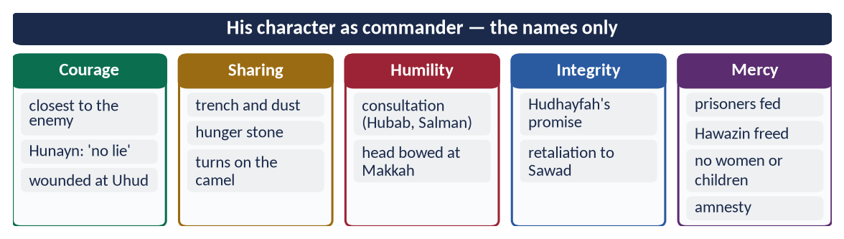
Figure 5 · At a glance — his character as commander — the names only. The detail is in the sections above.

(11) A general estimate
✦ HADITH
لَا تَتَمَنَّوْا لِقَاءَ الْعَدُوِّ، وَسَلُوا اللَّهَ الْعَافِيَةَ، فَإِذَا لَقِيتُمُوهُمْ فَاصْبِرُوا
“Do not wish to meet the enemy, and ask Allah for safety; but when you meet them, be steadfast.” (Al-Bukhari and Muslim)
➜ He prayed for peace and stood firm in war.

The overall estimate is this: he was a man of peace who led in war — the bravest in danger, the humblest in victory, the most just to his own men and the most merciful to his enemies. Other commanders won battles; he won the loyalty of his soldiers and the hearts of his enemies, which is why the Quraysh, the Hawazin and the Thaqif — his opponents on the field — became his followers within two years.
✦ SCHOLARLY VIEW
Sir William Muir · The Life of Mahomet
Even Muir, a critical writer, admitted that in the hour of triumph at Makkah the Prophet ﷺ showed magnanimity and moderation towards the people who had long persecuted him.
➜ Admission from a critic carries extra weight.

Why this answer scores
- It answers character, not strategy — the one thing that separates 2019 from 2016.
- Every quality is placed in a named battle, as 'in the battlefields' demands.
- It ends with a real 'general estimate' — an overall judgement supported by a hadith and a critic's admission.

Answer 3 · The Ghazwat Were Fought to Establish Peace (CSS 2024)
THE QUESTION · CSS 2024 · Q3 · 20 marks
The main purpose of Ghazwat-e-Nabawi was to establish peace. Explain.

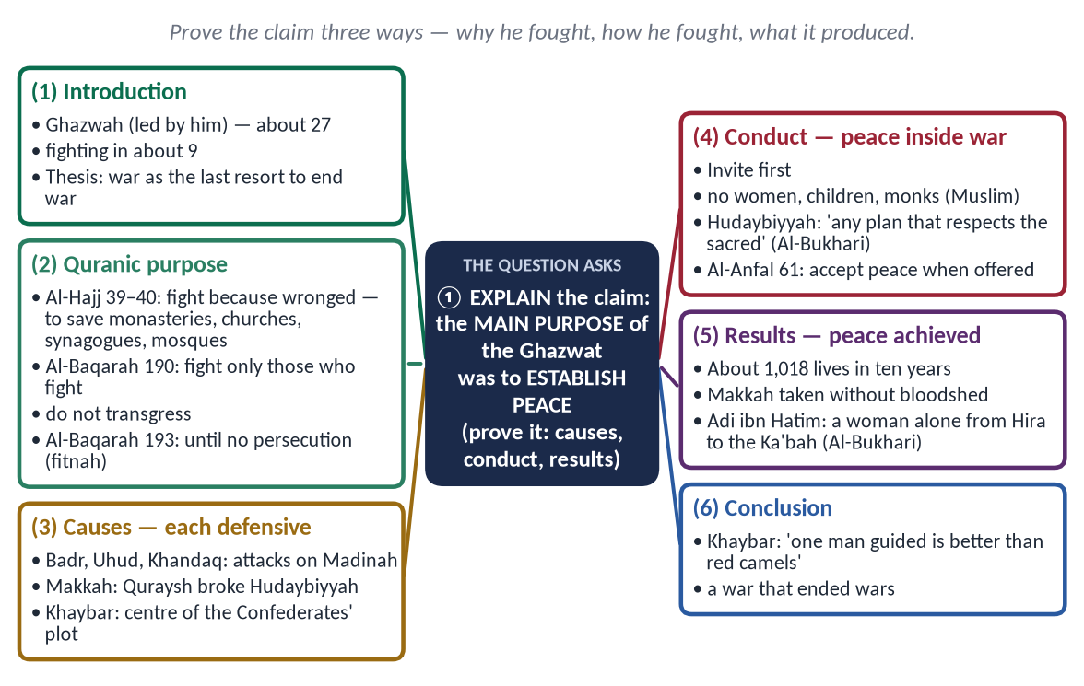
Figure 6 · The answer map: every branch is one numbered heading of the model answer below.

Decoding the question
- 'Explain' = give reasons and evidence that prove the claim.
- 'Main purpose' = show that other aims (wealth, land, forced conversion) were not the goal.
- 'Establish peace' = show peace in the causes, the conduct and the results of the Ghazwat.

The model answer

(1) Introduction
Ghazwat-e-Nabawi (غَزَوَاتِ نَبَوِي) are the expeditions the Prophet ﷺ led in person — about 27, with fighting in about nine. Critics call them wars of expansion. The evidence shows the opposite: they were forced on the Muslims, fought by rules that protected the innocent, and ended in the first lasting peace Arabia had known. War was the means; peace was the purpose.
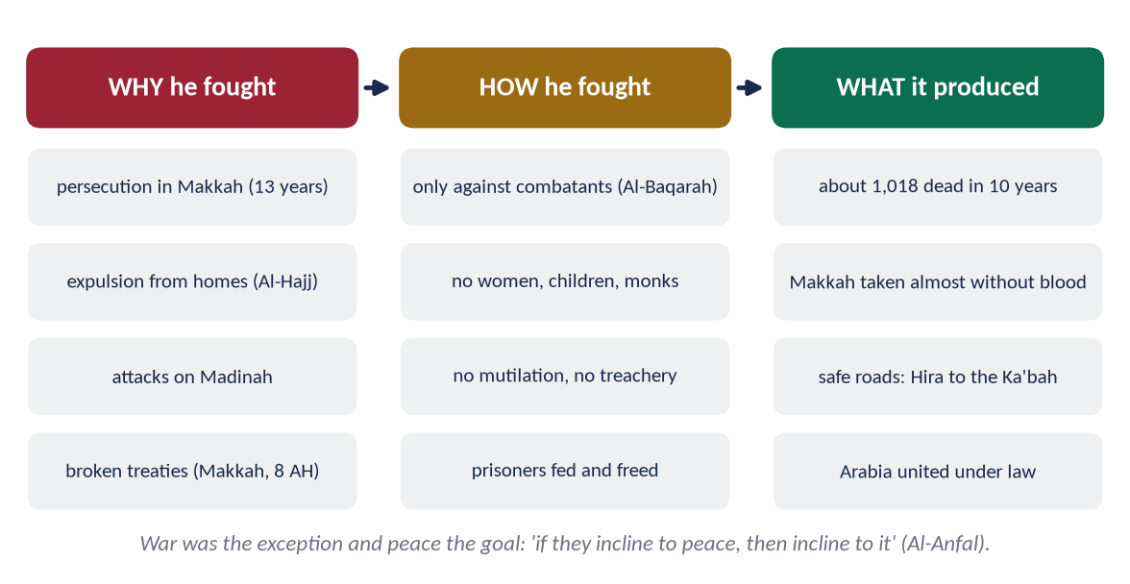
Figure 7 · Why he fought, how he fought, and what the Ghazwat produced.

(2) The Quranic purpose of fighting — peace and freedom

(i) Only after oppression
✦ QURAN
﴿أُذِنَ لِلَّذِينَ يُقَٰتَلُونَ بِأَنَّهُمۡ ظُلِمُواْۚ وَإِنَّ ٱللَّهَ عَلَىٰ نَصۡرِهِمۡ لَقَدِيرٌ﴾
“Permission [to fight] has been given to those who are being fought, because they were wronged. And indeed, Allah is competent to give them victory.” (Al-Hajj, Quran)
➜ Permission to fight is given to those who are fought against, because they have been wronged.

✦ QURAN
﴿… وَلَوۡلَا دَفۡعُ ٱللَّهِ ٱلنَّاسَ بَعۡضَهُم بِبَعۡضٖ لَّهُدِّمَتۡ صَوَٰمِعُ وَبِيَعٞ وَصَلَوَٰتٞ وَمَسَٰجِدُ يُذۡكَرُ فِيهَا ٱسۡمُ ٱللَّهِ كَثِيرٗاۗ …﴾
“Were it not that Allah checks some people by means of others, monasteries, churches, synagogues and mosques — in which Allah's name is much mentioned — would have been demolished.” (Al-Hajj, Quran)
➜ Without defence, monasteries, churches, synagogues and mosques would be destroyed — war to protect the freedom of worship of all.

(ii) Only against those who fight
✦ QURAN
﴿وَقَٰتِلُواْ فِي سَبِيلِ ٱللَّهِ ٱلَّذِينَ يُقَٰتِلُونَكُمۡ وَلَا تَعۡتَدُوٓاْۚ إِنَّ ٱللَّهَ لَا يُحِبُّ ٱلۡمُعۡتَدِينَ﴾
“Fight in the way of Allah those who fight you but do not transgress. Indeed. Allah does not like transgressors.” (Al-Baqarah, Quran)
➜ Fight those who fight you, but do not transgress.

(iii) To end persecution, then stop
✦ QURAN
﴿وَقَٰتِلُوهُمۡ حَتَّىٰ لَا تَكُونَ فِتۡنَةٞ وَيَكُونَ ٱلدِّينُ لِلَّهِۖ فَإِنِ ٱنتَهَوۡاْ فَلَا عُدۡوَٰنَ إِلَّا عَلَى ٱلظَّـٰلِمِينَ﴾
“Fight them until there is no [more] fitnah and [until] worship is [acknowledged to be] for Allah. But if they cease, then there is to be no aggression except against the oppressors.” (Al-Baqarah, Quran)
➜ Fight until there is no more fitnah; if they stop, there is no hostility except against oppressors.

(iv) Peace as soon as it is offered
✦ QURAN
﴿وَإِن جَنَحُواْ لِلسَّلۡمِ فَٱجۡنَحۡ لَهَا وَتَوَكَّلۡ عَلَى ٱللَّهِۚ إِنَّهُۥ هُوَ ٱلسَّمِيعُ ٱلۡعَلِيمُ﴾
“And if they incline to peace, then incline to it [also] and rely upon Allah. Indeed, it is He who is the Hearing, the Knowing.” (Al-Anfal, Quran)
➜ 'If they incline to peace, incline to it.'

(3) The causes — every Ghazwah was defensive or against a breach
Ghazwah | Cause | Peace it secured
Badr (2 AH) | Quraysh marched with about 1,000 to crush Madinah | Broke the rule of force in Arabia
Uhud (3 AH) | 3,000 Quraysh attacked Madinah | Defence of the city
Khandaq (5 AH) | 10,000 Confederates besieged Madinah | 'Now we go to them; they will not come to us' (Al-Bukhari) — attacks on Madinah ended
Khaybar (7 AH) | Base of the plot that raised the Confederates | Northern threat ended; land left with its people
Makkah (8 AH) | Quraysh broke Hudaybiyyah (Banu Bakr against Khuza'ah) | Taken almost without blood; general amnesty
Hunayn (8 AH) | Hawazin gathered 20,000 to attack | Captives returned; Hawazin became allies
Tabuk (9 AH) | Byzantine threat on the border | No battle; treaties of protection

(4) The conduct — peace inside war

(i) Invitation before fighting
✦ HADITH
اغْزُوا بِاسْمِ اللَّهِ ... وَلَا تَغُلُّوا، وَلَا تَغْدِرُوا، وَلَا تَمْثُلُوا، وَلَا تَقْتُلُوا وَلِيدًا
“Fight in the name of Allah … do not steal from the spoils, do not betray, do not mutilate, do not kill a child.” (Muslim)
➜ Every commander had to offer Islam or peace first (the hadith of Buraydah).

(ii) Non-combatants protected
✦ HADITH
فَنَهَى رَسُولُ اللَّهِ ﷺ عَنْ قَتْلِ النِّسَاءِ وَالصِّبْيَانِ
“The Messenger of Allah ﷺ forbade the killing of women and children.” (Al-Bukhari and Muslim)
➜ The first principle of humanitarian law.

(iii) Peace accepted even on hard terms
✦ HADITH
وَالَّذِي نَفْسِي بِيَدِهِ لَا يَسْأَلُونِي خُطَّةً يُعَظِّمُونَ فِيهَا حُرُمَاتِ اللَّهِ إِلَّا أَعْطَيْتُهُمْ إِيَّاهَا
“By the One in whose hand is my soul, whatever plan they propose that respects the sanctities of Allah, I will grant it.” (Al-Bukhari)
➜ At Hudaybiyyah he chose a treaty over a battle he could have fought.

(iv) Not wishing for war
✦ HADITH
لَا تَتَمَنَّوْا لِقَاءَ الْعَدُوِّ، وَسَلُوا اللَّهَ الْعَافِيَةَ
“Do not wish to meet the enemy; ask Allah for safety.” (Al-Bukhari and Muslim)
➜ A commander who prayed for peace.

(5) What the purpose was NOT
- Not wealth: he died with his armour pledged for barley.
- Not land for its own sake: Khaybar's land was left with its people for half the produce.
- Not forced conversion: 'No compulsion in religion' (Al-Baqarah 256); the Christians of Najran and Aylah kept their faith by treaty.
- Not revenge: Makkah, the city of his persecutors, was forgiven.

(6) The results — peace established

(i) The least bloodshed in any revolution
About 1,018 lives on both sides in ten years (Qazi Sulaiman Mansurpuri) — compared with about 17 million in the First World War and 70–85 million in the Second.

(ii) Safe roads across Arabia
✦ HADITH
فَلَيُوشِكَنَّ أَنْ تَرَى الظَّعِينَةَ تَرْتَحِلُ مِنَ الْحِيرَةِ حَتَّى تَطُوفَ بِالْكَعْبَةِ لَا تَخَافُ أَحَدًا إِلَّا اللَّهَ
“You will soon see a woman travel from Hira to circle the Ka'bah, fearing no one but Allah.” (Al-Bukhari)
➜ Adi ibn Hatim (RA) lived to see it — the Ghazwat ended in security.

(iii) Enemies became brothers
The Quraysh, Hawazin and Thaqif — all opponents in battle — joined Islam within two years.
✦ QURAN
﴿وَٱعۡتَصِمُواْ بِحَبۡلِ ٱللَّهِ جَمِيعٗا وَلَا تَفَرَّقُواْۚ وَٱذۡكُرُواْ نِعۡمَتَ ٱللَّهِ عَلَيۡكُمۡ إِذۡ كُنتُمۡ أَعۡدَآءٗ فَأَلَّفَ بَيۡنَ قُلُوبِكُمۡ فَأَصۡبَحۡتُم بِنِعۡمَتِهِۦٓ إِخۡوَٰنٗا …﴾
“And hold firmly to the rope of Allah all together and do not become divided. Remember Allah's favour upon you: you were enemies, and He brought your hearts together, and by His favour you became brothers.” (Aal-e-Imran, Quran)
➜ 'You were enemies and He brought your hearts together.'

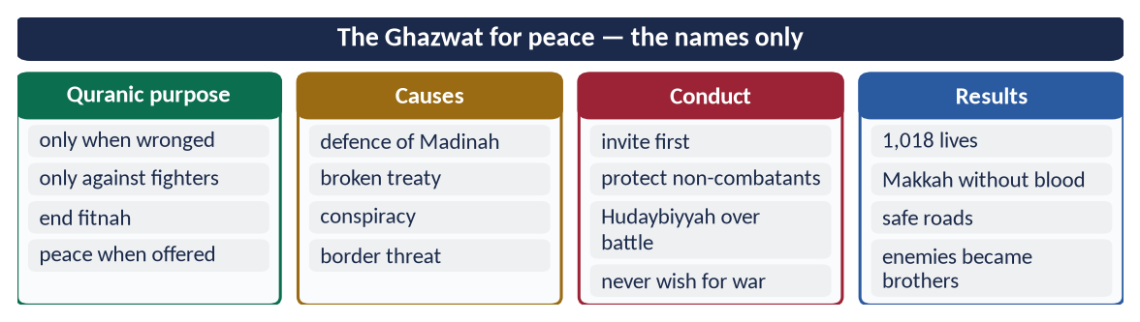
Figure 8 · At a glance — the Ghazwat for peace — the names only. The detail is in the sections above.

(7) Conclusion
✦ HADITH
فَوَاللَّهِ لَأَنْ يَهْدِيَ اللَّهُ بِكَ رَجُلًا وَاحِدًا خَيْرٌ لَكَ مِنْ أَنْ يَكُونَ لَكَ حُمْرُ النَّعَمِ
“By Allah, that Allah guides one man through you is better for you than the finest red camels.” (Al-Bukhari and Muslim)
➜ Said to Ali (RA) at Khaybar as he took the flag.

The causes, the conduct and the results of the Ghazwat point to one purpose: to end persecution and establish a just peace. The Prophet ﷺ fought few battles, with few deaths, by strict rules, and each ended in a treaty, an amnesty or an alliance. The Ghazwat were wars that ended war in Arabia — the clearest proof that the Prophet of mercy remained the Prophet of mercy even with a sword in hand.

Why this answer scores
- It proves the claim three ways — causes, conduct, results — exactly as 'explain' requires.
- It also shows what the purpose was not, closing the door on the counter-argument.
- A table of seven battles, the 1,018 figure and the Adi ibn Hatim hadith give hard evidence.

Answer 4 · The Greatest Peace Maker: Reconciliation with Pagans, Jews and Christians (CSS 2017)
THE QUESTION · CSS 2017 · Q5 · 20 marks
Elucidate how the Prophet of Islam (Peace be upon him) exemplified him as the greatest peace maker in the world by making reconciliation with pagans, Jews and Christians?

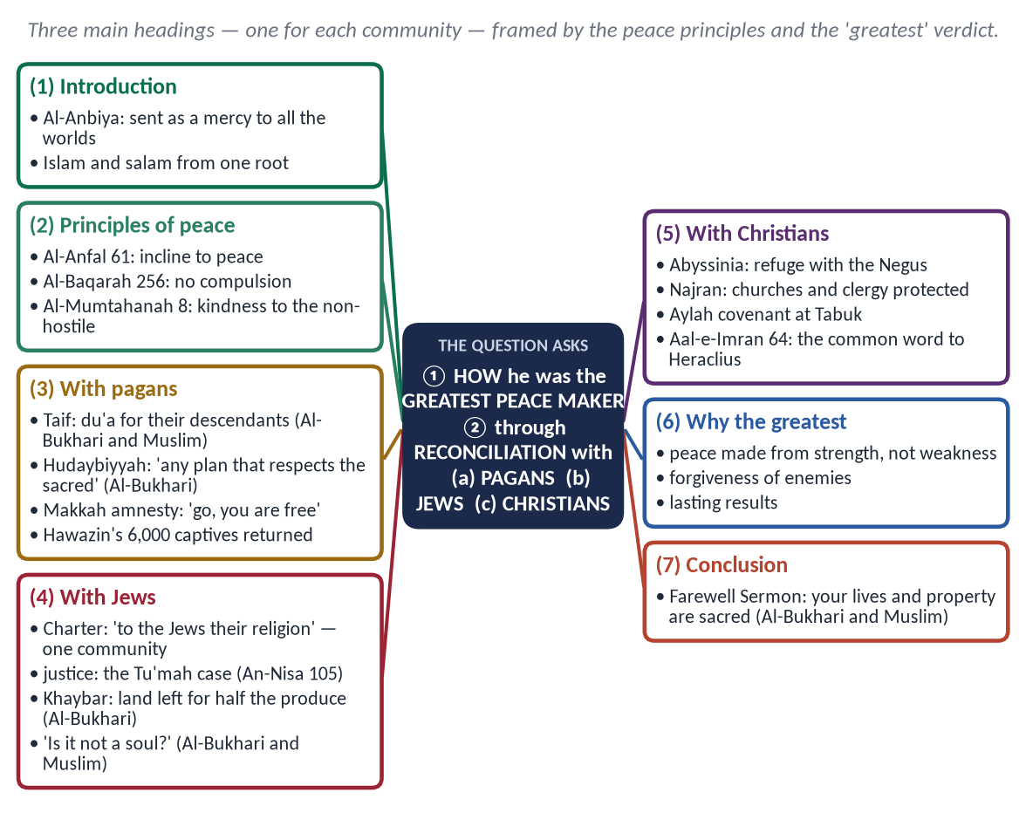
Figure 9 · The answer map: every branch is one numbered heading of the model answer below.

Decoding the question
- 'Elucidate how' = explain the methods by which he made peace, with examples.
- 'Reconciliation with pagans, Jews and Christians' = three separate headings; balance them.
- 'Greatest peace maker in the world' = end with why he is the greatest — a comparative judgement.

The model answer

(1) Introduction
✦ QURAN
﴿وَمَآ أَرۡسَلۡنَٰكَ إِلَّا رَحۡمَةٗ لِّلۡعَٰلَمِينَ﴾
“And We have not sent you, [O Muhammad], except as a mercy to the worlds.” (Al-Anbiya, Quran)
➜ He was sent as a mercy to all the worlds — not to one community.

Islam (إِسْلَام) and salam (سَلَام) come from one root. The Prophet ﷺ lived among three communities that were at first hostile: the pagans of Makkah, the Jews of Madinah and the Christians of Arabia and beyond. With each he sought reconciliation — by patience, treaties, justice and forgiveness — and with each he left a model that the world still studies.

(2) The principles on which he made peace
✦ QURAN
﴿وَإِن جَنَحُواْ لِلسَّلۡمِ فَٱجۡنَحۡ لَهَا وَتَوَكَّلۡ عَلَى ٱللَّهِۚ إِنَّهُۥ هُوَ ٱلسَّمِيعُ ٱلۡعَلِيمُ﴾
“And if they incline to peace, then incline to it [also] and rely upon Allah. Indeed, it is He who is the Hearing, the Knowing.” (Al-Anfal, Quran)
➜ 'If they incline to peace, incline to it' — peace preferred whenever offered.

✦ QURAN
﴿لَآ إِكۡرَاهَ فِي ٱلدِّينِۖ قَد تَّبَيَّنَ ٱلرُّشۡدُ مِنَ ٱلۡغَيِّۚ …﴾
“There is no compulsion in religion; the right course has become clear from the wrong.” (Al-Baqarah, Quran)
➜ No compulsion in religion — reconciliation never meant forced conversion.

✦ QURAN
﴿لَّا يَنۡهَىٰكُمُ ٱللَّهُ عَنِ ٱلَّذِينَ لَمۡ يُقَٰتِلُوكُمۡ فِي ٱلدِّينِ وَلَمۡ يُخۡرِجُوكُم مِّن دِيَٰرِكُمۡ أَن تَبَرُّوهُمۡ وَتُقۡسِطُوٓاْ إِلَيۡهِمۡۚ إِنَّ ٱللَّهَ يُحِبُّ ٱلۡمُقۡسِطِينَ﴾
“Allah does not forbid you from those who do not fight you because of religion and do not expel you from your homes - from being righteous toward them and acting justly toward them. Indeed, Allah loves those who act justly.” (Al-Mumtahanah, Quran)
➜ Allah does not forbid kindness and justice to those who do not fight you.

(3) Reconciliation with the pagans (Mushrikin)

(i) Thirteen years of patience in Makkah
Under boycott, torture and murder of his Companions, he did not allow retaliation.

(ii) Taif — du'a instead of destruction
✦ HADITH
بَلْ أَرْجُو أَنْ يُخْرِجَ اللَّهُ مِنْ أَصْلَابِهِمْ مَنْ يَعْبُدُ اللَّهَ وَحْدَهُ
“Rather, I hope that Allah will bring from their descendants those who will worship Allah alone.” (Al-Bukhari and Muslim)
➜ Offered the destruction of Taif, he chose hope.

(iii) Hudaybiyyah — peace on hard terms
✦ HADITH
وَالَّذِي نَفْسِي بِيَدِهِ لَا يَسْأَلُونِي خُطَّةً يُعَظِّمُونَ فِيهَا حُرُمَاتِ اللَّهِ إِلَّا أَعْطَيْتُهُمْ إِيَّاهَا
“Whatever plan they propose that respects the sanctities of Allah, I will grant it.” (Al-Bukhari)
➜ He accepted a ten-year truce, erased 'Messenger of Allah' from the text and returned Abu Jandal — for peace.

(iv) The Conquest of Makkah — the general amnesty
✦ QURAN
﴿قَالَ لَا تَثۡرِيبَ عَلَيۡكُمُ ٱلۡيَوۡمَۖ يَغۡفِرُ ٱللَّهُ لَكُمۡۖ وَهُوَ أَرۡحَمُ ٱلرَّـٰحِمِينَ﴾
“He said, "No blame will there be upon you today. Allah will forgive you; and He is the most merciful of the merciful.” (Yusuf, Quran)
➜ 'No blame upon you today' — the words of Yusuf, repeated to the Quraysh.

'Go, you are free.' Whoever entered the house of Abu Sufyan, shut his own door, or entered the Mosque was safe (Muslim). Hind, Wahshi, Ikrimah and Habbar were forgiven.

(v) Hunayn and Taif
He returned 6,000 captives of Hawazin to their families; the Thaqif of Taif, who had stoned him, came as a delegation in 9 AH and were received with honour.

(4) Reconciliation with the Jews

(i) The Charter of Madinah — one community
✦ FROM THE SIRAH
وَإِنَّ يَهُودَ بَنِي عَوْفٍ أُمَّةٌ مَعَ الْمُؤْمِنِينَ، لِلْيَهُودِ دِينُهُمْ وَلِلْمُسْلِمِينَ دِينُهُمْ
“The Jews of Banu Awf are one community with the believers: to the Jews their religion, and to the Muslims theirs.” (Sirat Ibn Hisham (the Charter))
➜ Citizens with equal protection, keeping their own faith.

(ii) Justice without bias
When a Muslim, Tu'mah, stole and accused a Jew, revelation cleared the Jew:
✦ QURAN
﴿إِنَّآ أَنزَلۡنَآ إِلَيۡكَ ٱلۡكِتَٰبَ بِٱلۡحَقِّ لِتَحۡكُمَ بَيۡنَ ٱلنَّاسِ بِمَآ أَرَىٰكَ ٱللَّهُۚ وَلَا تَكُن لِّلۡخَآئِنِينَ خَصِيمٗا﴾
“Indeed, We have revealed to you, [O Muhammad], the Book in truth so you may judge between the people by that which Allah has shown you. And do not be for the deceitful an advocate.” (An-Nisa, Quran)
➜ 'Judge between the people by what Allah has shown you, and do not be an advocate for the treacherous.'

(iii) Khaybar — tolerance after war
✦ HADITH
أَعْطَى رَسُولُ اللَّهِ ﷺ خَيْبَرَ الْيَهُودَ أَنْ يَعْمَلُوهَا وَيَزْرَعُوهَا، وَلَهُمْ شَطْرُ مَا يَخْرُجُ مِنْهَا
“The Messenger of Allah ﷺ gave Khaybar to the Jews to work and cultivate, for half of what it produced.” (Al-Bukhari)
➜ The defeated kept their land and livelihood; the woman who poisoned him was forgiven.

(iv) Human relations
✦ HADITH
أَلَيْسَتْ نَفْسًا
“Is it not a soul?” (Al-Bukhari and Muslim)
➜ He stood for a Jewish funeral; he visited a sick Jewish boy and pledged his armour with a Jewish trader.

The tribes of Qaynuqa, Nadir and Qurayzah left Madinah only after each broke the Charter; those who kept it remained in peace.

(5) Reconciliation with the Christians

(i) Abyssinia — the Christian refuge
He sent the persecuted Muslims to the Negus, 'a king in whose land no one is wronged'. When the Negus died, the Prophet ﷺ led the funeral prayer for him in absence (Al-Bukhari).

(ii) Najran — a written charter of rights
✦ FROM THE SIRAH
وَلِنَجْرَانَ وَحَاشِيَتِهَا جِوَارُ اللَّهِ وَذِمَّةُ مُحَمَّدٍ النَّبِيِّ عَلَى أَمْوَالِهِمْ وَمِلَّتِهِمْ وَبِيَعِهِمْ
“For Najran and its people there is the protection of Allah and the guarantee of Muhammad the Prophet — for their property, their religion and their churches.” (Imam Abu Yusuf, Kitab al-Kharaj; Ibn Sa'd)
➜ The delegation prayed in the Mosque of Madinah.

(iii) Aylah — protection at the frontier
At Tabuk (9 AH) he gave Yuhanna ibn Ru'bah, the Christian ruler of Aylah, a covenant protecting his people, ships and caravans.

(iv) Dialogue on common ground
✦ QURAN
﴿قُلۡ يَـٰٓأَهۡلَ ٱلۡكِتَٰبِ تَعَالَوۡاْ إِلَىٰ كَلِمَةٖ سَوَآءِۭ بَيۡنَنَا وَبَيۡنَكُمۡ أَلَّا نَعۡبُدَ إِلَّا ٱللَّهَ وَلَا نُشۡرِكَ بِهِۦ شَيۡـٔٗا وَلَا يَتَّخِذَ بَعۡضُنَا بَعۡضًا أَرۡبَابٗا مِّن دُونِ ٱللَّهِۚ …﴾
“Say: O People of the Scripture, come to a word common between us and you: that we worship none but Allah, associate nothing with Him, and that none of us take others as lords besides Allah.” (Aal-e-Imran, Quran)
➜ 'Come to a word common between us and you' — written to Heraclius, the Christian emperor.

✦ QURAN
﴿… وَلَتَجِدَنَّ أَقۡرَبَهُم مَّوَدَّةٗ لِّلَّذِينَ ءَامَنُواْ ٱلَّذِينَ قَالُوٓاْ إِنَّا نَصَٰرَىٰۚ ذَٰلِكَ بِأَنَّ مِنۡهُمۡ قِسِّيسِينَ وَرُهۡبَانٗا وَأَنَّهُمۡ لَا يَسۡتَكۡبِرُونَ﴾
“You will find the nearest of them in affection to the believers those who say, 'We are Christians' — that is because among them are priests and monks, and they are not arrogant.” (Al-Ma'idah, Quran)
➜ The nearest in affection to the believers are those who say, 'We are Christians'.

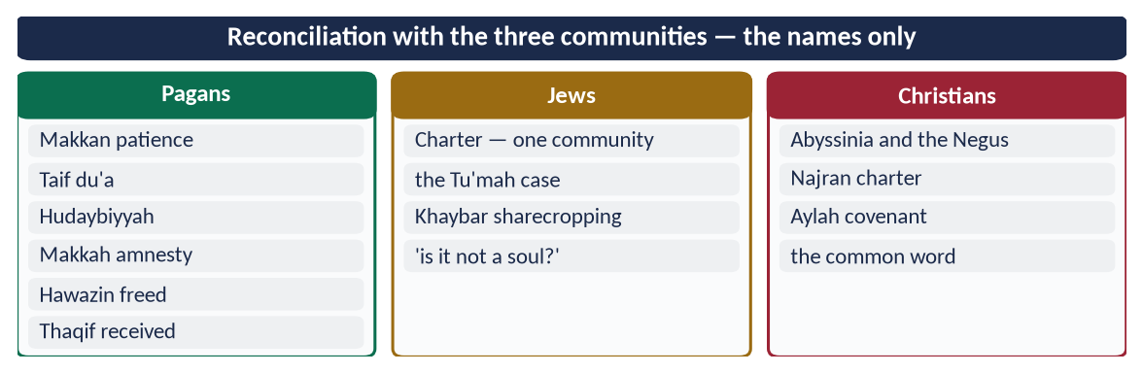
Figure 10 · At a glance — reconciliation with the three communities — the names only. The detail is in the sections above.

(6) Why he is the greatest peace maker in the world
- (a) Peace from strength: he forgave Makkah when he held it at his mercy — not as a weak party.
- (b) Peace with every community: idolaters, Jews and Christians — no other leader of his age made written peace with all three.
- (c) Peace written into law: the Charter and the treaties gave rights that could be claimed.
- (d) Peace that lasted: Arabia, at war for centuries, became one people within a decade.
✦ SCHOLARLY VIEW
Michael H. Hart · The 100 (1978)
Hart placed the Prophet ﷺ first among the most influential persons because he succeeded on both the religious and the secular levels — and peace-making was central to his secular success.
➜ A neutral judgement.

(7) Conclusion
✦ HADITH
إِنَّ دِمَاءَكُمْ وَأَمْوَالَكُمْ حَرَامٌ عَلَيْكُمْ كَحُرْمَةِ يَوْمِكُمْ هَذَا
“Your lives and your property are sacred to one another, like the sanctity of this day.” (Al-Bukhari and Muslim)
➜ The last word of his mission, at the Farewell Sermon.

He reconciled with the pagans by patience, treaty and forgiveness; with the Jews by a shared constitution and impartial justice; and with the Christians by refuge, charters and dialogue. That is why he is not only a peace maker, but the peace maker — the model for a divided world today.

Why this answer scores
- Three equal headings for the three communities the question names.
- Each reconciliation is shown by method (patience, treaty, justice, charter), answering 'elucidate how'.
- It closes with a reasoned 'why the greatest' — the comparative claim the question makes.

Answer 5 · A Prophet of Peace for the Contemporary Transnational World (CSS 2022 and 2018)
THE QUESTION · CSS 2022 · Q6 · 20 marks
Describe Hazrat Muhammad (ﷺ) as a Prophet of Peace for contemporary transnational world.

SAME THEME, OTHER YEAR · CSS 2018 · Q8
'The Holy Prophet (PBUH) is the prophet of peace and safety. Explain with arguments.' Use headings (2)–(4) of this answer, add a heading 'Safety (aman) of life, property and honour' (the Farewell Sermon; 'the believer is one whom people trust'; Al-Ma'idah 32), and replace heading (5) with peace with other communities from Answer 4.

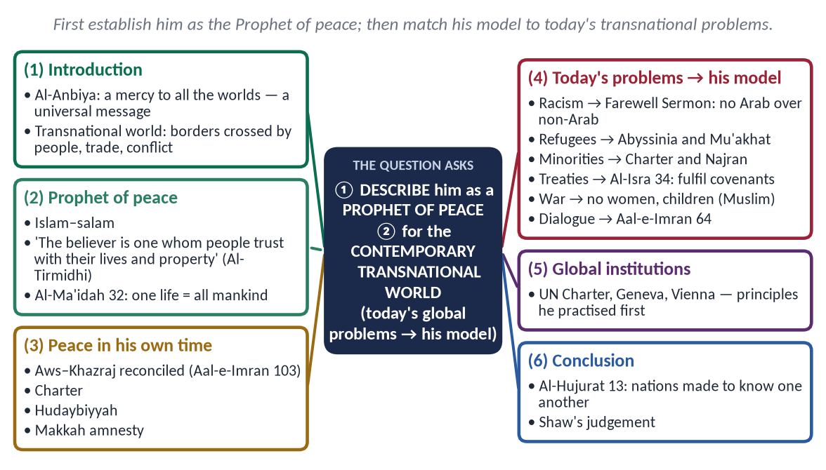
Figure 11 · The answer map: every branch is one numbered heading of the model answer below.

Decoding the question
- 'Describe' = present a full picture, with evidence.
- 'Prophet of Peace' = establish the concept first (salam, safety, reconciliation).
- 'Contemporary transnational world' = today's problems that cross borders — migration, racism, minorities, terrorism, war, treaties, dialogue, environment — and his answer to each. This limb decides the marks.

The model answer

(1) Introduction
✦ QURAN
﴿وَمَآ أَرۡسَلۡنَٰكَ إِلَّا رَحۡمَةٗ لِّلۡعَٰلَمِينَ﴾
“And We have not sent you, [O Muhammad], except as a mercy to the worlds.” (Al-Anbiya, Quran)
➜ He was sent as a mercy to all the worlds — a message addressed to humanity, not to one nation.

The world today is transnational: people, money, ideas, disease and war cross borders freely. Over 120 million people are forcibly displaced; racism, terrorism, Islamophobia and wars in Gaza and elsewhere show that global peace is still missing. The Prophet ﷺ, whose own world was divided by tribe, race and religion, created a peaceful order out of it. His model speaks directly to this age.

(2) The Prophet ﷺ as a Prophet of peace

(i) Peace in the name of the religion
Islam (إِسْلَام) and salam (سَلَام) share one root; As-Salam is a name of Allah; Paradise is Dar as-Salam.

(ii) The Muslim as a source of safety for all people
✦ HADITH
وَالْمُؤْمِنُ مَنْ أَمِنَهُ النَّاسُ عَلَى دِمَائِهِمْ وَأَمْوَالِهِمْ
“The believer is the one whom people trust with their lives and their property.” (Al-Tirmidhi and Al-Nasa'i)
➜ Not only Muslims — all people must be safe from a believer.

(iii) The value of one life
✦ QURAN
﴿… مَن قَتَلَ نَفۡسَۢا بِغَيۡرِ نَفۡسٍ أَوۡ فَسَادٖ فِي ٱلۡأَرۡضِ فَكَأَنَّمَا قَتَلَ ٱلنَّاسَ جَمِيعٗا وَمَنۡ أَحۡيَاهَا فَكَأَنَّمَآ أَحۡيَا ٱلنَّاسَ جَمِيعٗاۚ …﴾
“Whoever kills a soul — unless for a soul or for corruption in the land — it is as if he had slain mankind entirely; and whoever saves one, it is as if he had saved mankind entirely.” (Al-Ma'idah, Quran)
➜ Killing one innocent soul is like killing all mankind.

(3) Peace in his own time — the proof of the model
- Aws and Khazraj, at war for a century, made brothers (Aal-e-Imran 103).
- The Charter of Madinah — one state for Muslims, Jews and Arab clans.
- Hudaybiyyah — a ten-year truce accepted on hard terms.
- The Conquest of Makkah — a city taken with an amnesty, not a massacre.

(4) His model for the problems of the transnational world

(i) Racism and nationalism
✦ FROM THE SIRAH
لَا فَضْلَ لِعَرَبِيٍّ عَلَى عَجَمِيٍّ، وَلَا لِعَجَمِيٍّ عَلَى عَرَبِيٍّ، وَلَا لِأَحْمَرَ عَلَى أَسْوَدَ، وَلَا أَسْوَدَ عَلَى أَحْمَرَ، إِلَّا بِالتَّقْوَى
“No Arab has superiority over a non-Arab, nor a non-Arab over an Arab, nor white over black, nor black over white — except by taqwa.” (Musnad Ahmad (the Farewell Sermon))
➜ The answer to racism and ethnic hatred.

✦ QURAN
﴿يَـٰٓأَيُّهَا ٱلنَّاسُ إِنَّا خَلَقۡنَٰكُم مِّن ذَكَرٖ وَأُنثَىٰ وَجَعَلۡنَٰكُمۡ شُعُوبٗا وَقَبَآئِلَ لِتَعَارَفُوٓاْۚ إِنَّ أَكۡرَمَكُمۡ عِندَ ٱللَّهِ أَتۡقَىٰكُمۡۚ إِنَّ ٱللَّهَ عَلِيمٌ خَبِيرٞ﴾
“O mankind, indeed We have created you from male and female and made you peoples and tribes that you may know one another. Indeed, the most noble of you in the sight of Allah is the most righteous of you. Indeed, Allah is Knowing and Acquainted.” (Al-Hujurat, Quran)
➜ Nations and tribes exist to know one another — diversity is for cooperation.

(ii) Refugees and migration
The Muslims were refugees twice: to Abyssinia, where a Christian king protected them, and to Madinah, where the Mu'akhat made every refugee a brother with home and work — integration without camps.
✦ QURAN
﴿وَإِنۡ أَحَدٞ مِّنَ ٱلۡمُشۡرِكِينَ ٱسۡتَجَارَكَ فَأَجِرۡهُ حَتَّىٰ يَسۡمَعَ كَلَٰمَ ٱللَّهِ ثُمَّ أَبۡلِغۡهُ مَأۡمَنَهُۥۚ ذَٰلِكَ بِأَنَّهُمۡ قَوۡمٞ لَّا يَعۡلَمُونَ﴾
“And if any one of the polytheists seeks your protection, then grant him protection so that he may hear the words of Allah. Then deliver him to his place of safety. That is because they are a people who do not know.” (At-Tawbah, Quran)
➜ Whoever seeks your protection, protect him and take him to safety.

(iii) Minorities and pluralism
The Charter of Madinah ('to the Jews their religion') and the Najran treaty (churches and clergy protected) are models for the rights of minorities anywhere.
✦ HADITH
مَنْ قَتَلَ مُعَاهَدًا لَمْ يَرِحْ رَائِحَةَ الْجَنَّةِ
“Whoever kills a non-Muslim under covenant will not smell the fragrance of Paradise.” (Al-Bukhari)
➜ The strongest protection for minorities.

(iv) International treaties and the rule of law
✦ QURAN
﴿… وَأَوۡفُواْ بِٱلۡعَهۡدِۖ إِنَّ ٱلۡعَهۡدَ كَانَ مَسۡـُٔولٗا﴾
“And fulfil every commitment; indeed, the commitment will be questioned about.” (Al-Isra, Quran)
➜ 'Fulfil every commitment; it will be asked about.'

He kept Hudaybiyyah even when it meant returning Abu Jandal — the model for respecting international agreements.

(v) War, terrorism and civilians
✦ HADITH
فَنَهَى رَسُولُ اللَّهِ ﷺ عَنْ قَتْلِ النِّسَاءِ وَالصِّبْيَانِ
“He forbade the killing of women and children.” (Al-Bukhari and Muslim)
➜ The Prophetic law of war condemns terrorism and the bombing of civilians alike.

(vi) Diplomacy and dialogue
✦ QURAN
﴿قُلۡ يَـٰٓأَهۡلَ ٱلۡكِتَٰبِ تَعَالَوۡاْ إِلَىٰ كَلِمَةٖ سَوَآءِۭ بَيۡنَنَا وَبَيۡنَكُمۡ أَلَّا نَعۡبُدَ إِلَّا ٱللَّهَ وَلَا نُشۡرِكَ بِهِۦ شَيۡـٔٗا وَلَا يَتَّخِذَ بَعۡضُنَا بَعۡضًا أَرۡبَابٗا مِّن دُونِ ٱللَّهِۚ …﴾
“Say: O People of the Scripture, come to a word common between us and you: that we worship none but Allah, associate nothing with Him, and that none of us take others as lords besides Allah.” (Aal-e-Imran, Quran)
➜ 'Come to a word common between us and you.'

Letters to eight rulers, delegations received in the Mosque, envoys protected: 'were it not that envoys are not killed…' (Abu Dawud).

(vii) Economic justice and the environment
Zakat and the ban on hoarding answer global inequality; the order not to cut fruit trees even in war, and 'if the Hour comes and one of you has a sapling, let him plant it' (Ahmad), answer the climate crisis.
Transnational problem | The Prophetic model | Modern parallel
Racism | Farewell Sermon; Al-Hujurat 13 | UN Convention on Racial Discrimination (1965)
Refugees | Abyssinia; Mu'akhat; At-Tawbah 6 | Refugee Convention (1951)
Minorities | Charter of Madinah; Najran | Minority rights; Article 36 (Pakistan)
Treaties | Al-Isra 34; Hudaybiyyah kept | Vienna Convention on Treaties (1969)
War and terror | Buraydah hadith; no civilians | Geneva Conventions (1949)
Diplomacy | Letters; immunity of envoys | Vienna Convention (1961)
Dialogue | Aal-e-Imran 64; Najran debate | A Common Word (2007)
Poverty, climate | Zakat; trees protected | SDGs; Paris Agreement (2015)

(5) What the world has said
✦ SCHOLARLY VIEW
George Bernard Shaw · The Genuine Islam (1936)
Shaw wrote that if a man like Muhammad were to lead the modern world, he would solve its problems in a way that would bring it the peace and happiness it needs.
➜ A Western writer's view of his relevance today.

(6) Conclusion
✦ QURAN
﴿يَـٰٓأَيُّهَا ٱلنَّاسُ إِنَّا خَلَقۡنَٰكُم مِّن ذَكَرٖ وَأُنثَىٰ وَجَعَلۡنَٰكُمۡ شُعُوبٗا وَقَبَآئِلَ لِتَعَارَفُوٓاْۚ إِنَّ أَكۡرَمَكُمۡ عِندَ ٱللَّهِ أَتۡقَىٰكُمۡۚ إِنَّ ٱللَّهَ عَلِيمٌ خَبِيرٞ﴾
“O mankind, indeed We have created you from male and female and made you peoples and tribes that you may know one another. Indeed, the most noble of you in the sight of Allah is the most righteous of you. Indeed, Allah is Knowing and Acquainted.” (Al-Hujurat, Quran)
➜ The most honoured of you in the sight of Allah is the most righteous — not the richest nation or the strongest race.

The transnational world has written laws for peace — the UN Charter, the Geneva and Vienna Conventions — but keeps breaking them. The Prophet ﷺ practised these principles fourteen centuries earlier and, more importantly, joined them to character and accountability before Allah. He is therefore not a figure of the past but a Prophet of peace for this age: for the refugee, the minority, the victim of racism and the civilian under bombardment.

Why this answer scores
- It gives the 'transnational' limb its full weight — eight modern problems, each matched to a Prophetic model and a modern parallel.
- It first proves 'Prophet of peace' from the Quran and Hadith, then brings it to today.
- The 'same theme' box turns it into a ready answer for 2018.

Answer 6 · The Peace Agreements of the Prophetic Era: Contents and Parties (CSS 2025)
THE QUESTION · CSS 2025 · Q6 · 20 marks
Discuss the contents of the peace agreements made during the Prophet's era, identifying the parties to those agreements.

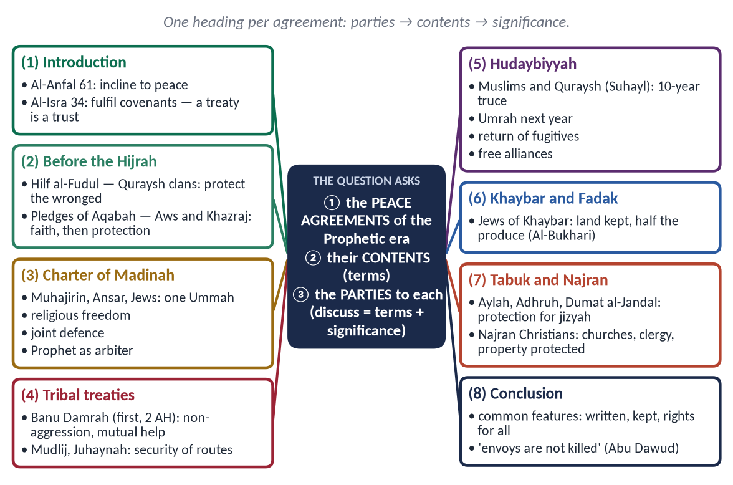
Figure 12 · The answer map: every branch is one numbered heading of the model answer below.

Decoding the question
- 'Contents' = the terms of each agreement — the core of the answer.
- 'Identifying the parties' = name both sides of every agreement clearly.
- 'Discuss' = add the significance and common features.
- Arrange chronologically and put a summary table at the end.

The model answer

(1) Introduction
✦ QURAN
﴿وَإِن جَنَحُواْ لِلسَّلۡمِ فَٱجۡنَحۡ لَهَا وَتَوَكَّلۡ عَلَى ٱللَّهِۚ إِنَّهُۥ هُوَ ٱلسَّمِيعُ ٱلۡعَلِيمُ﴾
“And if they incline to peace, then incline to it [also] and rely upon Allah. Indeed, it is He who is the Hearing, the Knowing.” (Al-Anfal, Quran)
➜ 'If they incline to peace, incline to it.'

✦ QURAN
﴿… وَأَوۡفُواْ بِٱلۡعَهۡدِۖ إِنَّ ٱلۡعَهۡدَ كَانَ مَسۡـُٔولٗا﴾
“And fulfil every commitment; indeed, the commitment will be questioned about.” (Al-Isra, Quran)
➜ 'Fulfil every commitment; the commitment will be asked about.'

The Prophet ﷺ made more agreements than he fought battles. From a pact for justice as a young man to treaties with Christian rulers in his last years, he used agreements to protect the weak, secure the state and open the way for his message. Below, each agreement is given with its parties and contents.

(2) Hilf al-Fudul — the League of the Virtuous (c. 590)
- Parties: the clans of Quraysh — Hashim, Muttalib, Zuhrah, Taym and Asad — meeting in the house of Abdullah ibn Jud'an; the young Muhammad ﷺ was present.
- Contents: to stand with anyone wronged in Makkah, citizen or stranger, until his right is restored.
✦ FROM THE SIRAH
وَلَوْ أُدْعَى بِهِ فِي الْإِسْلَامِ لَأَجَبْتُ
“If I were invited to it in Islam, I would accept.” (Al-Bayhaqi; Sirat Ibn Hisham)
➜ He approved it after Prophethood — cooperation with others for justice.

(3) The Pledges of Aqabah (621 and 622)
- Parties: the Prophet ﷺ and men (and two women) of the Aws and Khazraj of Yathrib.
- Contents: first pledge (12 men) — not to associate partners with Allah, steal, commit adultery, kill children or slander; second pledge (73 men, 2 women) — to protect him as they protected their own families. It opened the way for the Hijrah.

(4) The Charter of Madinah (1 AH / 622)
- Parties: the Muhajirin of Quraysh, the Ansar (Aws and Khazraj clans), the Jewish tribes of Yathrib and their allies.
- Contents:
- (a) All parties form one community (Ummah) distinct from others.
- (b) Religious freedom — 'to the Jews their religion and to the Muslims theirs'.
- (c) Disputes referred to Allah and Muhammad ﷺ.
- (d) Joint defence of Madinah; each party bears its own costs; no protection for the Quraysh.
- (e) Yathrib a sanctuary; guilt is personal; blood-money paid by the clans.
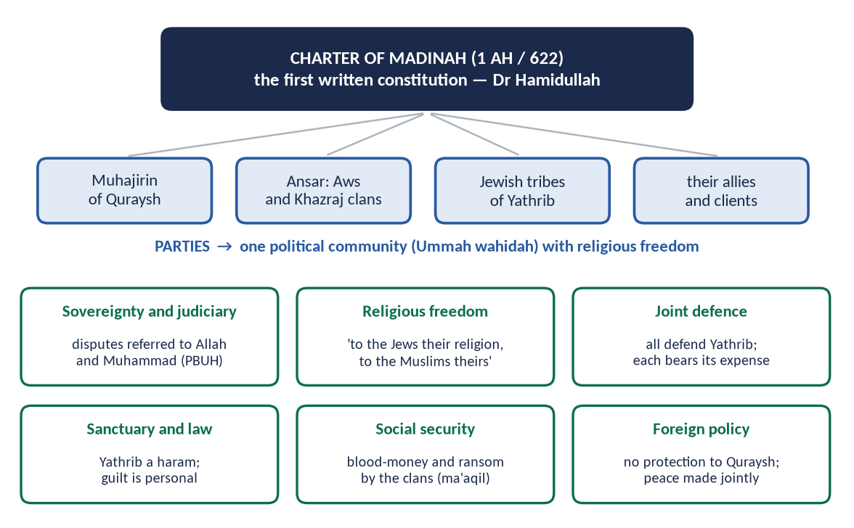
Figure 13 · The parties and provisions of the Charter of Madinah.

(5) Treaties with the tribes around Madinah (2 AH)
- Banu Damrah (with their chief Makhshi ibn Amr) — the first treaty with a non-Muslim tribe: neither side to attack the other; each to help the other when called; their lives and property safe.
- Banu Mudlij and Juhaynah — non-aggression on the coastal routes.

(6) The Treaty of Hudaybiyyah (6 AH / 628)
- Parties: the Muslims of Madinah, led by the Prophet ﷺ, and the Quraysh of Makkah, represented by Suhayl ibn Amr.
- Contents:
# | Term
1 | No war for ten years; people to be safe from each other.
2 | Muslims return this year; perform Umrah next year for three days, with sheathed swords.
3 | A Makkan who goes to Madinah without his guardian's leave is returned; a Muslim going to Makkah is not.
4 | Tribes free to ally with either side — Khuza'ah with the Muslims, Banu Bakr with the Quraysh.

✦ QURAN
﴿إِنَّا فَتَحۡنَا لَكَ فَتۡحٗا مُّبِينٗا﴾
“Indeed, We have given you, [O Muhammad], a clear conquest.” (Al-Fath, Quran)
➜ 'A clear victory' — the Quran's verdict on this treaty.

(7) The agreement of Khaybar and Fadak (7 AH)
- Parties: the Muslims and the Jews of Khaybar; separately, the people of Fadak.
- Contents:
✦ HADITH
أَعْطَى رَسُولُ اللَّهِ ﷺ خَيْبَرَ الْيَهُودَ أَنْ يَعْمَلُوهَا وَيَزْرَعُوهَا، وَلَهُمْ شَطْرُ مَا يَخْرُجُ مِنْهَا
“The Messenger of Allah ﷺ gave Khaybar to the Jews to work and cultivate, and they would have half of what it produced.” (Al-Bukhari)
➜ Land and livelihood left with its people; Fadak made peace on half its produce without fighting.

(8) The treaties of Tabuk (9 AH)
- Parties: the Muslims and Yuhanna ibn Ru'bah, Christian ruler of Aylah; the people of Adhruh, Jarba and Maqna; Ukaydir of Dumat al-Jandal.
- Contents: protection of life, property, ships and caravans by land and sea, and freedom of religion, in return for an annual jizyah — a tax in place of military service.

(9) The treaty of Najran (9–10 AH)
- Parties: the Prophet ﷺ and the Christians of Najran, whose delegation came to Madinah.
- Contents: protection of their churches, clergy, religion and property; no bishop or monk to be removed; no interference in their faith; in return 2,000 robes a year (Abu Dawud).
✦ FROM THE SIRAH
وَلِنَجْرَانَ وَحَاشِيَتِهَا جِوَارُ اللَّهِ وَذِمَّةُ مُحَمَّدٍ النَّبِيِّ عَلَى أَمْوَالِهِمْ وَمِلَّتِهِمْ وَبِيَعِهِمْ
“For Najran and its people there is the protection of Allah and the guarantee of Muhammad the Prophet — for their property, their religion and their churches.” (Imam Abu Yusuf, Kitab al-Kharaj; Ibn Sa'd)
➜ A written guarantee of religious freedom.

(10) The agreement with Thaqif (9 AH)
- Parties: the Prophet ﷺ and the delegation of Thaqif of Taif.
- Contents: the valley of Taif protected; the people accepted Islam; their idol (al-Lat) removed by others, not by their own hands — a sensitive term respected.

(11) Summary table
Agreement | Date | Parties | Core content
Hilf al-Fudul | c. 590 | Quraysh clans | Protect the wronged
Aqabah I and II | 621–622 | The Prophet ﷺ; Aws, Khazraj | Faith; protection
Charter of Madinah | 1 AH | Muhajirin, Ansar, Jews | One Ummah; freedom; defence
Banu Damrah | 2 AH | Muslims; Banu Damrah | Non-aggression; help
Hudaybiyyah | 6 AH | Muslims; Quraysh | Ten-year truce
Khaybar, Fadak | 7 AH | Muslims; Jews of Khaybar | Half the produce
Tabuk treaties | 9 AH | Aylah, Adhruh, Dumat al-Jandal | Protection for jizyah
Najran | 9–10 AH | Christians of Najran | Churches protected
Thaqif | 9 AH | Taif | Valley protected

(12) Common features of the agreements
- (a) Written and witnessed — a new practice in an oral culture.
- (b) Kept faithfully — Abu Jandal returned; no Muslim breach recorded.
- (c) Rights for all parties — religion, property and life guaranteed.
- (d) Flexibility in form — 'Bismika Allahumma' accepted at Hudaybiyyah.
- (e) Peace as the goal — every treaty replaced a possible war.

(13) Conclusion
✦ HADITH
لَوْلَا أَنَّ الرُّسُلَ لَا تُقْتَلُ لَضَرَبْتُ أَعْنَاقَكُمَا
“Were it not that envoys are not killed, I would have struck your necks.” (Abu Dawud)
➜ Even envoys of an enemy were protected by law.

The peace agreements of the Prophetic era joined every community of his world — clans of Quraysh, Arab tribes, Jews and Christians — in written, faithfully kept covenants. They are the foundation of Islamic international law (siyar), as Dr Muhammad Hamidullah showed, and a model for a world that signs treaties but too often breaks them.

Why this answer scores
- Every agreement has parties and contents as separate labelled lines — the two demands of the question.
- Chronological order plus a summary table make the answer easy to mark.
- Common features and a conclusion add the discussion.

Answer 7 · Short Notes: Hudaybiyyah as a Pact of Peace; the Benefits of Khaybar (CSS 2021)
THE QUESTION · CSS 2021 · Q8 · 20 marks (10 + 10)
Write notes on the following: (a) Treaty of Hudaybiyya as a pact of peace; (b) Benefits acquired from the Battle of Khaybar.

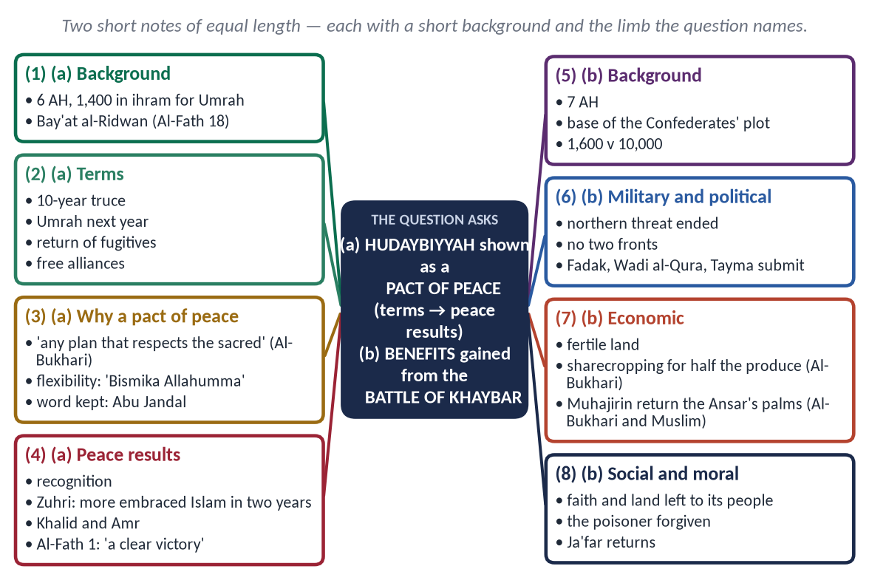
Figure 14 · The answer map: every branch is one numbered heading of the model answer below.

Decoding the question
- Two notes, 10 marks each — give each about equal space.
- (a) 'as a pact of peace' — not a general account: show how its terms, spirit and results made peace.
- (b) 'Benefits acquired' — group the benefits (military, political, economic, social), not a battle narrative.

The model answer

(a) The Treaty of Hudaybiyyah as a pact of peace

(i) Background
In Dhul Qa'dah 6 AH (628) the Prophet ﷺ set out with about 1,400 Companions for Umrah — in ihram, with sacrificial animals, carrying only sheathed swords. The Quraysh stopped them at Hudaybiyyah. When a rumour said his envoy Uthman (RA) was killed, the Companions pledged to stand by him:
✦ QURAN
﴿لَّقَدۡ رَضِيَ ٱللَّهُ عَنِ ٱلۡمُؤۡمِنِينَ إِذۡ يُبَايِعُونَكَ تَحۡتَ ٱلشَّجَرَةِ فَعَلِمَ مَا فِي قُلُوبِهِمۡ فَأَنزَلَ ٱلسَّكِينَةَ عَلَيۡهِمۡ وَأَثَٰبَهُمۡ فَتۡحٗا قَرِيبٗا﴾
“Certainly was Allah pleased with the believers when they pledged allegiance to you, [O Muhammad], under the tree, and He knew what was in their hearts, so He sent down tranquillity upon them and rewarded them with an imminent conquest.” (Al-Fath, Quran)
➜ Allah was pleased with the believers when they pledged allegiance under the tree.

(ii) The terms
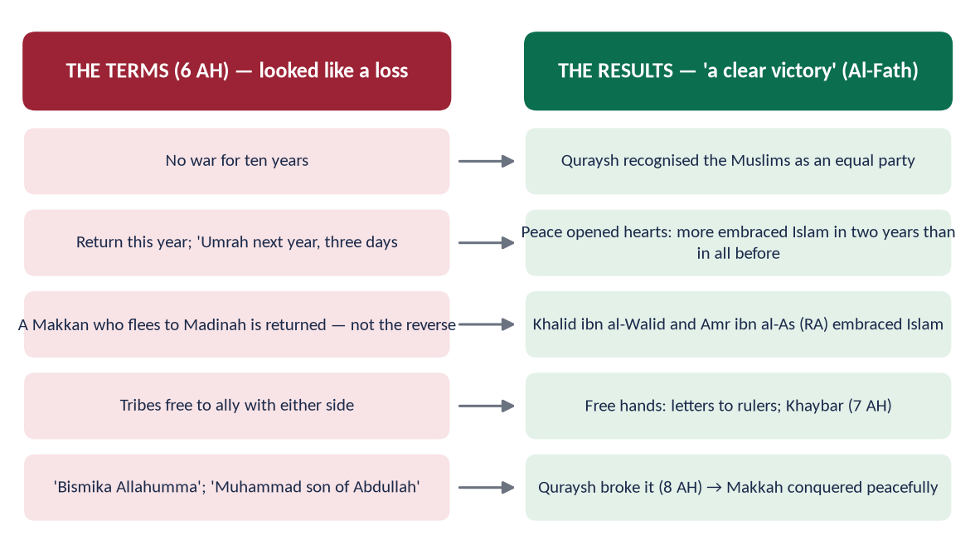
Figure 15 · The terms of Hudaybiyyah and what they produced.

(iii) Why it was a pact of peace
- The intention was peace: he came as a pilgrim, not a warrior.
✦ HADITH
وَالَّذِي نَفْسِي بِيَدِهِ لَا يَسْأَلُونِي خُطَّةً يُعَظِّمُونَ فِيهَا حُرُمَاتِ اللَّهِ إِلَّا أَعْطَيْتُهُمْ إِيَّاهَا
“Whatever plan they propose that respects the sanctities of Allah, I will grant it.” (Al-Bukhari)
➜ He declared himself ready for any honourable peace.

- Flexibility for peace: he accepted 'Bismika Allahumma' and 'Muhammad ibn Abdullah' in place of the Muslim wording.
- The truce itself: ten years without war — the first guaranteed peace between Makkah and Madinah.
- The word kept: Abu Jandal (RA) arrived in chains and was returned; the Muslims grieved, but the treaty held.

(iv) The peace it produced
✦ QURAN
﴿إِنَّا فَتَحۡنَا لَكَ فَتۡحٗا مُّبِينٗا﴾
“Indeed, We have given you, [O Muhammad], a clear conquest.” (Al-Fath, Quran)
➜ 'Indeed, We have given you a clear victory' — revealed on the way home.

- Recognition: the Quraysh treated the Muslims as an equal party.
- Dawah in peace: Imam al-Zuhri said no victory was greater: when people met without war, more embraced Islam in two years than in all the years before — 1,400 at Hudaybiyyah, 10,000 at Makkah.
- Khalid ibn al-Walid and Amr ibn al-As accepted Islam.
- Letters to the rulers and a free hand in the north.
- When the Quraysh themselves broke it (8 AH), Makkah was taken almost without bloodshed.
In short: Hudaybiyyah looked like a loss and was a victory — because peace, not war, carried Islam across Arabia.

(b) The benefits acquired from the Battle of Khaybar

(i) Background
Khaybar, a fortified oasis about 150 km north of Madinah, had become the base of the plots against Madinah: leaders of the exiled Banu Nadir had raised the Confederates of 5 AH and allied with Ghatafan. In Muharram 7 AH the Prophet ﷺ marched with about 1,600 men, cut Khaybar off from Ghatafan, and took its eight forts one by one; the flag of the final assault went to Ali (RA).

(ii) Military and political benefits
- The northern conspiracy ended — Madinah was safe from the north.
- No two-front war — with Quraysh bound by Hudaybiyyah and Khaybar subdued, the state was secure.
- Peaceful submission of Fadak, Wadi al-Qura and Tayma without fighting.
- A new balance — the Muslims became the leading power of Arabia.

(iii) Economic benefits
✦ HADITH
أَعْطَى رَسُولُ اللَّهِ ﷺ خَيْبَرَ الْيَهُودَ أَنْ يَعْمَلُوهَا وَيَزْرَعُوهَا، وَلَهُمْ شَطْرُ مَا يَخْرُجُ مِنْهَا
“He gave Khaybar to the Jews to work and cultivate, for half of what it produced.” (Al-Bukhari)
➜ A lasting model of sharecropping (muzara'ah) and state revenue.

✦ HADITH
رَدَّ الْمُهَاجِرُونَ إِلَى الْأَنْصَارِ مَنَائِحَهُمُ
“The Muhajirin returned to the Ansar the date palms they had been given.” (Al-Bukhari and Muslim)
➜ The refugees became self-supporting.

(iv) Social, moral and legal benefits
- Tolerance in victory: the people kept their homes, land and religion.
- Forgiveness: the woman who served him poisoned meat was pardoned for his own sake.
- Law: rules on booty, conquered land and sharecropping were settled.
- Reunion: Ja'far ibn Abi Talib (RA) and the emigrants of Abyssinia returned — 'I do not know which makes me happier: Khaybar or Ja'far' (Al-Hakim).
In short: Khaybar removed the last military threat to Madinah, gave the young state an economic base, and showed that even a victory in war was used to build peace and justice.

Why this answer scores
- Equal space for two 10-mark notes.
- Note (a) proves 'pact of peace' — intention, flexibility, truce, word kept, results.
- Note (b) gives benefits grouped by kind, with two hadith from Al-Bukhari as proof.

Answer 8 · The Charter of Madinah as a Social Contract (CSS 2020 and 2023)
THE QUESTION · CSS 2020 · Q6 · 20 marks
Analyze the Madina Accord as a "Social Contract" in detail.

SAME QUESTION, OTHER YEAR · CSS 2023 · Q6
'Analyze the Charter of Madina as a social contract.' The same answer serves; 2020 adds 'in detail' — give the full provisions (heading 4) and the modern comparison (heading 7).

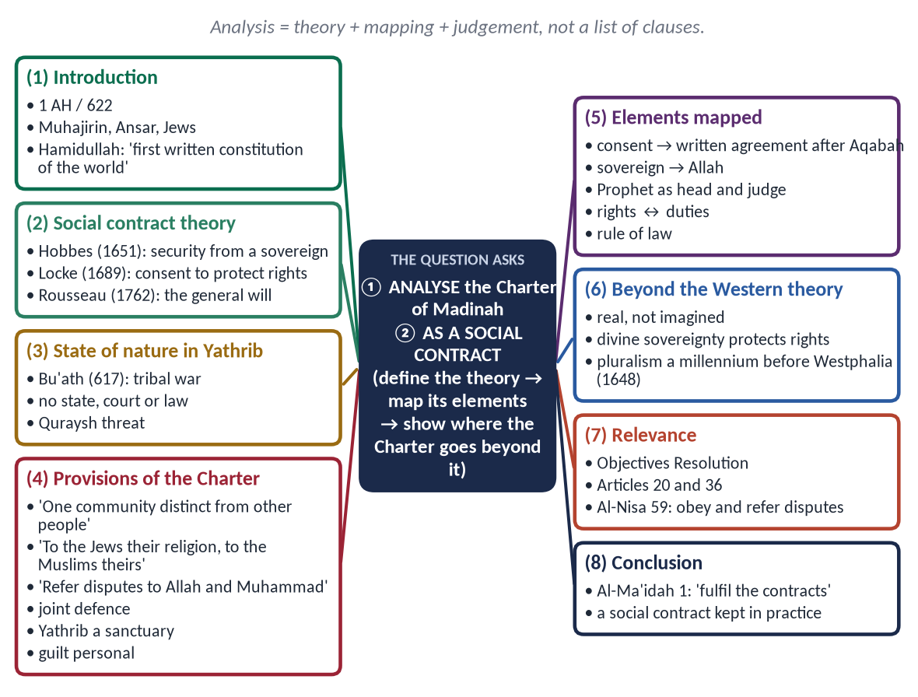
Figure 16 · The answer map: every branch is one numbered heading of the model answer below.

Decoding the question
- 'Analyze' = break into parts and judge — not just describe.
- 'As a social contract' = use the theory (Hobbes, Locke, Rousseau) as the measuring rod and test the Charter against each element.
- 'In detail' (2020) = full provisions and a modern comparison.

The model answer

(1) Introduction
The Charter of Madinah — Mithaq al-Madinah (مِيثَاقُ الْمَدِينَة) or Sahifat al-Madinah (صَحِيفَةُ الْمَدِينَة) — was drawn up by the Prophet ﷺ in 1 AH / 622, soon after the Hijrah, among the Muhajirin, the Ansar and the Jewish tribes of Yathrib. It is preserved by Ibn Ishaq (in Ibn Hisham) and Abu Ubayd and has about fifty clauses (counted from 47 to 53).
✦ SCHOLARLY VIEW
Dr Muhammad Hamidullah · The First Written Constitution in the World
Hamidullah called it 'the first written constitution of the world', because it defined a state, its citizens, its authority and its law in writing — centuries before Magna Carta (1215).
➜ The standard judgement.

This answer analyses the Charter as a social contract: it defines the theory, shows the 'state of nature' in Yathrib, sets out the Charter's terms, maps them onto the theory, and shows where the Charter goes beyond it.

(2) The theory of the social contract
A social contract is the agreement by which people leave a 'state of nature' without government and form a political society, accepting a common authority and law in exchange for security and rights.
Thinker | Work | Key idea
Thomas Hobbes | Leviathan (1651) | Life without a state is 'nasty, brutish and short'; people surrender power to a sovereign for security.
John Locke | Two Treatises of Government (1689) | People consent to government to protect life, liberty and property; power is limited.
J. J. Rousseau | The Social Contract (1762) | People bind themselves to laws of the general will; freedom through law.

(3) The 'state of nature' in Yathrib
- War of all against all: the Aws and Khazraj had fought for generations; the battle of Bu'ath (617) had exhausted both.
- No common authority: no ruler, no court, no written law — every clan was judge in its own case.
- A divided population: Arab clans, several Jewish tribes, and now the Muslim emigrants.
- External danger: the Quraysh threatened the Muslims.
This was precisely Hobbes' state of nature — and the people of Yathrib had invited the Prophet ﷺ at Aqabah to end it.

(4) The provisions of the Charter
Figure 17 · The parties and main provisions of the Charter of Madinah.

(i) A new political community
✦ FROM THE SIRAH
إِنَّهُمْ أُمَّةٌ وَاحِدَةٌ مِنْ دُونِ النَّاسِ
“They are one community (Ummah) distinct from all other people.” (Sirat Ibn Hisham (the Charter))
➜ Citizenship above tribe.

(ii) Religious freedom within the community
✦ FROM THE SIRAH
وَإِنَّ يَهُودَ بَنِي عَوْفٍ أُمَّةٌ مَعَ الْمُؤْمِنِينَ، لِلْيَهُودِ دِينُهُمْ وَلِلْمُسْلِمِينَ دِينُهُمْ
“The Jews of Banu Awf are one community with the believers: to the Jews their religion, and to the Muslims theirs.” (Sirat Ibn Hisham (the Charter))
➜ Membership without conversion.

(iii) Sovereignty and judiciary
✦ FROM THE SIRAH
وَإِنَّكُمْ مَهْمَا اخْتَلَفْتُمْ فِيهِ مِنْ شَيْءٍ فَإِنَّ مَرَدَّهُ إِلَى اللَّهِ وَإِلَى مُحَمَّدٍ
“Whatever you differ about is to be referred to Allah and to Muhammad.” (Sirat Ibn Hisham (the Charter))
➜ A central authority replaces tribal self-help.

(iv) Collective security
✦ FROM THE SIRAH
وَإِنَّ بَيْنَهُمُ النَّصْرَ عَلَى مَنْ حَارَبَ أَهْلَ هَذِهِ الصَّحِيفَةِ
“They shall help one another against whoever fights the people of this document.” (Sirat Ibn Hisham (the Charter))
➜ Joint defence; each party bears its own expenses; no protection to the Quraysh.

(v) Sanctuary, law and welfare
- Yathrib a sanctuary (haram) for all parties.
- Guilt is personal — no collective punishment of a tribe.
- Justice even against one's own: all stand against the wrongdoer 'even if he is the son of one of them'.
- Blood-money and ransom paid by the clans — an early system of social security.

(5) The Charter measured against the social contract
Element of a social contract | In the Charter of Madinah
State of nature | Tribal war (Bu'ath); no court, no ruler
Consent | Negotiated after the pledges of Aqabah; written and accepted by every party
Common authority | Allah as sovereign; the Prophet ﷺ as head of state and final judge
Security (Hobbes) | Joint defence; Yathrib a sanctuary
Rights (Locke) | Life, property, religion, protection of clients and neighbours
General will (Rousseau) | One Ummah — a shared identity above clans
Duties | Defence, sharing costs, loyalty, no help to enemies
Rule of law | Guilt personal; justice even against one's son

Judgement: every essential element of the social contract is present — and in written, practical form.

(6) Where the Charter goes beyond the Western social contract
- (a) Real, not hypothetical: Hobbes, Locke and Rousseau imagined a contract to explain the state; the Charter was actually made and signed in 622.
- (b) Divine sovereignty protects rights: because the source of law is Allah, basic rights cannot be removed by a majority or a ruler.
✦ QURAN
﴿… أَطِيعُواْ ٱللَّهَ وَأَطِيعُواْ ٱلرَّسُولَ وَأُوْلِي ٱلۡأَمۡرِ مِنكُمۡۖ فَإِن تَنَٰزَعۡتُمۡ فِي شَيۡءٖ فَرُدُّوهُ إِلَى ٱللَّهِ وَٱلرَّسُولِ …﴾
“Obey Allah and obey the Messenger and those in authority among you; and if you disagree over anything, refer it to Allah and the Messenger.” (An-Nisa, Quran)
➜ Obey Allah, the Messenger and those in authority; refer disputes to Allah and the Messenger — the constitutional principle of the Charter.

- (c) Pluralism from the start: it united people of different religions, while Europe fought wars of religion until the Peace of Westphalia (1648).
- (d) Moral foundation: loyalty rested on faith and justice, not on fear (Hobbes) or interest alone.
- (e) Tested in practice: when the tribes of Qaynuqa, Nadir and Qurayzah broke its terms, they were dealt with under the contract; those who kept it remained secure — a contract with real sanctions.

(7) Modern comparison and relevance
Principle | Charter of Madinah (622) | Modern constitution
Written constitution | About fifty clauses | Magna Carta 1215; US Constitution 1787
Citizenship | One Ummah above tribes | Equal citizenship
Freedom of religion | 'To the Jews their religion' | Article 20, Constitution of Pakistan
Minorities | Protected clients and allies | Article 36, Constitution of Pakistan
Judiciary | Refer to Allah and Muhammad ﷺ | Supreme Court
Sovereignty | Allah | Objectives Resolution (1949)

(8) Conclusion
✦ QURAN
﴿يَـٰٓأَيُّهَا ٱلَّذِينَ ءَامَنُوٓاْ أَوۡفُواْ بِٱلۡعُقُودِۚ …﴾
“O you who have believed, fulfil the contracts.” (Al-Ma'idah, Quran)
➜ 'O you who believe, fulfil the contracts.'

Analysed against the theory, the Charter of Madinah is a complete social contract: it ended a state of nature, rested on the consent of all parties, created a common authority, balanced rights with duties and established the rule of law. It also goes beyond the Western theory — it was real, plural and morally grounded. For Pakistan, whose Objectives Resolution also places sovereignty with Allah, it remains the founding model of a just, plural Islamic state.

Why this answer scores
- It analyses: theory → state of nature → provisions → mapping table → judgement.
- The Charter is quoted in its own Arabic words, four times.
- The 'beyond the theory' section and modern table give the critical depth examiners reward.

Answer 9 · The Status and Grade of Tolerance and Forgiveness in the Life of the Prophet ﷺ (CSS 2020)
THE QUESTION · CSS 2020 · Q2 · 20 marks
Discuss the status and grade of "Tolerance and Forgiveness" in the life of the Holy Prophet (PBUH).

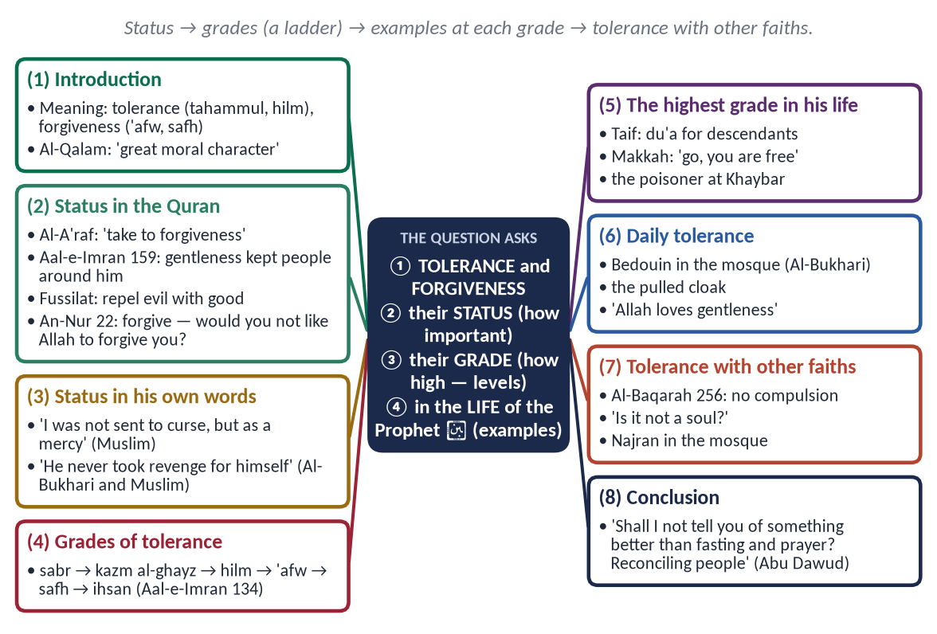
Figure 18 · The answer map: every branch is one numbered heading of the model answer below.

Decoding the question
- 'Status' = how important tolerance and forgiveness are — from the Quran and his own words.
- 'Grade' = levels — show that he reached the highest level. Most candidates miss this limb.
- 'In the life of the Holy Prophet' = real events, not general preaching.

The model answer

(1) Introduction
Tolerance — tahammul (تَحَمُّل) and hilm (حِلْم) — is bearing what one dislikes without reacting harshly. Forgiveness — 'afw (عَفْو) and safh (صَفْح) — is cancelling the punishment one has the right and power to take, and wiping the wrong from the heart.
✦ QURAN
﴿وَإِنَّكَ لَعَلَىٰ خُلُقٍ عَظِيمٖ﴾
“And indeed, you are of a great moral character.” (Al-Qalam, Quran)
➜ 'You are of a great moral character.'

In the life of the Prophet ﷺ, tolerance and forgiveness were not occasional acts; they were the ruling quality of his character, shown most when he had the most power.

(2) The status of tolerance and forgiveness

(i) In the Quran — commands addressed to him
✦ QURAN
﴿خُذِ ٱلۡعَفۡوَ وَأۡمُرۡ بِٱلۡعُرۡفِ وَأَعۡرِضۡ عَنِ ٱلۡجَٰهِلِينَ﴾
“Take what is given freely, enjoin what is good, and turn away from the ignorant.” (Al-A'raf, Quran)
➜ 'Take to forgiveness, enjoin what is good, and turn away from the ignorant.'

✦ QURAN
﴿فَبِمَا رَحۡمَةٖ مِّنَ ٱللَّهِ لِنتَ لَهُمۡۖ وَلَوۡ كُنتَ فَظًّا غَلِيظَ ٱلۡقَلۡبِ لَٱنفَضُّواْ مِنۡ حَوۡلِكَۖ …﴾
“So by mercy from Allah you were gentle with them; had you been harsh and hard-hearted, they would have scattered from around you.” (Aal-e-Imran, Quran)
➜ By Allah's mercy you were gentle with them; had you been harsh, they would have scattered.

✦ QURAN
﴿وَلَا تَسۡتَوِي ٱلۡحَسَنَةُ وَلَا ٱلسَّيِّئَةُۚ ٱدۡفَعۡ بِٱلَّتِي هِيَ أَحۡسَنُ فَإِذَا ٱلَّذِي بَيۡنَكَ وَبَيۡنَهُۥ عَدَٰوَةٞ كَأَنَّهُۥ وَلِيٌّ حَمِيمٞ﴾
“And not equal are the good deed and the bad. Repel [evil] by that [deed] which is better; and thereupon the one whom between you and him is enmity [will become] as though he was a devoted friend.” (Fussilat, Quran)
➜ 'Repel evil with what is better' — and the enemy becomes a close friend.

✦ QURAN
﴿… وَلۡيَعۡفُواْ وَلۡيَصۡفَحُوٓاْۗ أَلَا تُحِبُّونَ أَن يَغۡفِرَ ٱللَّهُ لَكُمۡۚ …﴾
“Let them pardon and overlook. Would you not like Allah to forgive you?” (An-Nur, Quran)
➜ 'Let them pardon and overlook. Would you not like Allah to forgive you?'

(ii) In his own words and life
✦ HADITH
إِنِّي لَمْ أُبْعَثْ لَعَّانًا، وَإِنَّمَا بُعِثْتُ رَحْمَةً
“I was not sent as one who curses; I was sent only as a mercy.” (Muslim)
➜ Refusing to curse the idolaters.

✦ HADITH
مَا انْتَقَمَ لِنَفْسِهِ فِي شَيْءٍ قَطُّ، إِلَّا أَنْ تُنْتَهَكَ حُرْمَةُ اللَّهِ
“He never took revenge for himself in anything, unless Allah's sanctity was violated.” (Al-Bukhari and Muslim)
➜ Hazrat Aishah (RA) — personal wrongs forgiven; only Allah's law enforced.

(3) The grades of tolerance and forgiveness
✦ QURAN
﴿ٱلَّذِينَ يُنفِقُونَ فِي ٱلسَّرَّآءِ وَٱلضَّرَّآءِ وَٱلۡكَٰظِمِينَ ٱلۡغَيۡظَ وَٱلۡعَافِينَ عَنِ ٱلنَّاسِۗ وَٱللَّهُ يُحِبُّ ٱلۡمُحۡسِنِينَ﴾
“Who spend [in the cause of Allah] during ease and hardship and who restrain anger and who pardon the people - and Allah loves the doers of good.” (Aal-e-Imran, Quran)
➜ Those who restrain anger and pardon people — and Allah loves the doers of good: three rising grades in one verse.

Grade | Arabic | In his life
1. Sabr — patience | صَبْر | Thirteen years of persecution in Makkah without retaliation.
2. Kazm al-ghayz — restraining anger | كَظْمُ الْغَيْظ | The Bedouin who pulled his cloak until it marked his neck.
3. Hilm — forbearance with power | حِلْم | The Bedouin in the mosque; the Companions stopped.
4. 'Afw — pardon | عَفْو | The woman who poisoned him at Khaybar.
5. Safh — wiping it from the heart | صَفْح | Wahshi, Hind, Ikrimah and Habbar received as Muslims.
6. Ihsan — returning good for evil | إِحْسَان | Du'a for the people of Taif; his shirt for Ibn Ubayy's shroud.

He did not stop at the lower grades: at every test he rose to 'afw, safh and ihsan — the highest grades.

(4) The highest grade in the great tests

(i) Taif — ihsan in humiliation
✦ HADITH
بَلْ أَرْجُو أَنْ يُخْرِجَ اللَّهُ مِنْ أَصْلَابِهِمْ مَنْ يَعْبُدُ اللَّهَ وَحْدَهُ لَا يُشْرِكُ بِهِ شَيْئًا
“Rather, I hope that Allah will bring from their descendants people who worship Allah alone.” (Al-Bukhari and Muslim)
➜ Stoned and bleeding, he refused the angel's offer to destroy them.

(ii) The Conquest of Makkah — forgiveness in total victory
✦ QURAN
﴿قَالَ لَا تَثۡرِيبَ عَلَيۡكُمُ ٱلۡيَوۡمَۖ يَغۡفِرُ ٱللَّهُ لَكُمۡۖ وَهُوَ أَرۡحَمُ ٱلرَّـٰحِمِينَ﴾
“He said, "No blame will there be upon you today. Allah will forgive you; and He is the most merciful of the merciful.” (Yusuf, Quran)
➜ 'No blame upon you today; Allah will forgive you.'

✦ FROM THE SIRAH
اذْهَبُوا فَأَنْتُمُ الطُّلَقَاءُ
“Go, you are all free.” (Sirat Ibn Hisham)
➜ A general amnesty for twenty years of persecution.

He forgave Hind, who had mutilated his uncle Hamzah; Wahshi, who had killed Hamzah; Ikrimah, son of Abu Jahl; and Habbar, whose attack had led to the death of his daughter Zaynab.

(iii) Khaybar — pardon of an attempted murder
A woman served him poisoned meat; asked 'Shall we kill her?', he said 'No' (Al-Bukhari and Muslim).

(iv) Abdullah ibn Ubayy — good for the worst enemy within
The leader of the hypocrites who slandered his wife was given the Prophet's ﷺ shirt for his shroud and his funeral prayer (Al-Bukhari).

(5) Tolerance in daily life
✦ HADITH
دَعُوهُ ... فَإِنَّمَا بُعِثْتُمْ مُيَسِّرِينَ، وَلَمْ تُبْعَثُوا مُعَسِّرِينَ
“Leave him … you were sent to make things easy, not hard.” (Al-Bukhari)
➜ The Bedouin who urinated in the mosque was taught gently.

✦ HADITH
مَهْلًا يَا عَائِشَةُ، إِنَّ اللَّهَ يُحِبُّ الرِّفْقَ فِي الْأَمْرِ كُلِّهِ
“Gently, O Aishah; Allah loves gentleness in every matter.” (Al-Bukhari and Muslim)
➜ His answer to men who greeted him with 'death be upon you'.

Anas (RA) served him for ten years and said he never once said 'uff' to him or asked 'why did you do this?' (Al-Bukhari and Muslim).

(6) Religious tolerance
✦ QURAN
﴿لَآ إِكۡرَاهَ فِي ٱلدِّينِۖ قَد تَّبَيَّنَ ٱلرُّشۡدُ مِنَ ٱلۡغَيِّۚ …﴾
“There is no compulsion in religion; the right course has become clear from the wrong.” (Al-Baqarah, Quran)
➜ No compulsion in religion.

✦ HADITH
أَلَيْسَتْ نَفْسًا
“Is it not a soul?” (Al-Bukhari and Muslim)
➜ He stood for a Jewish funeral.

The Christians of Najran prayed in his Mosque; the Charter of Madinah guaranteed 'to the Jews their religion'.
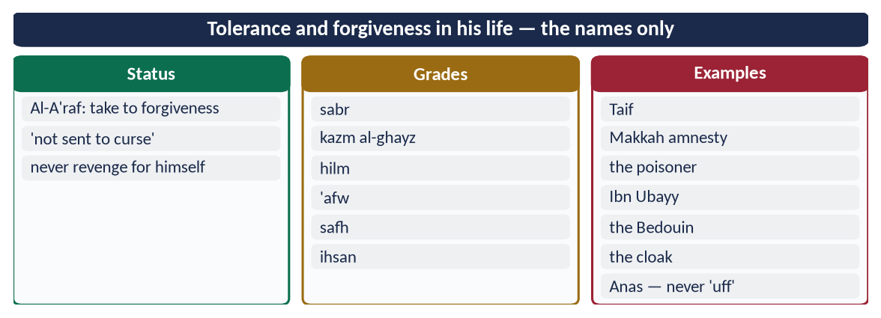
Figure 19 · At a glance — tolerance and forgiveness in his life — the names only. The detail is in the sections above.

(7) The limit — forgiveness is not weakness
He forgave personal wrongs, not crimes against others or against Allah's law: when a noblewoman of Makhzum stole, he refused intercession — 'if Fatimah daughter of Muhammad stole, I would cut her hand' (Al-Bukhari and Muslim). Forgiveness was his right to give; justice was others' right to receive.

(8) Conclusion
✦ HADITH
أَلَا أُخْبِرُكُمْ بِأَفْضَلَ مِنْ دَرَجَةِ الصِّيَامِ وَالصَّلَاةِ وَالصَّدَقَةِ؟ ... صَلَاحُ ذَاتِ الْبَيْنِ
“Shall I not tell you of something higher in rank than fasting, prayer and charity? … Reconciling between people.” (Abu Dawud and Al-Tirmidhi)
➜ He ranked reconciliation above voluntary worship.

In the life of the Prophet ﷺ, tolerance and forgiveness hold the highest status — commanded by the Quran, declared by himself as the purpose of his mercy — and reach the highest grade: not only patience and restraint, but pardon, overlooking and returning good for evil, shown when he had full power to punish. For a society like ours, torn by anger and revenge, this is the most needed part of his Sunnah.

Why this answer scores
- It answers both 'status' and 'grade' — the grade limb, with a six-level ladder, is what most candidates miss.
- Each grade has an event from his life.
- The limit (forgiveness is not injustice) shows balanced understanding.

Answer 10 · Makarim al-Akhlaq and Social Peace; How the Prophet ﷺ Completed the Morals (CSS 2025)
THE QUESTION · CSS 2025 · Q2 · 20 marks
What is the importance of Makarim Akhlaq (noble morals) in establishing social peace? In this background, how did the Messenger of Allah complete these morals?

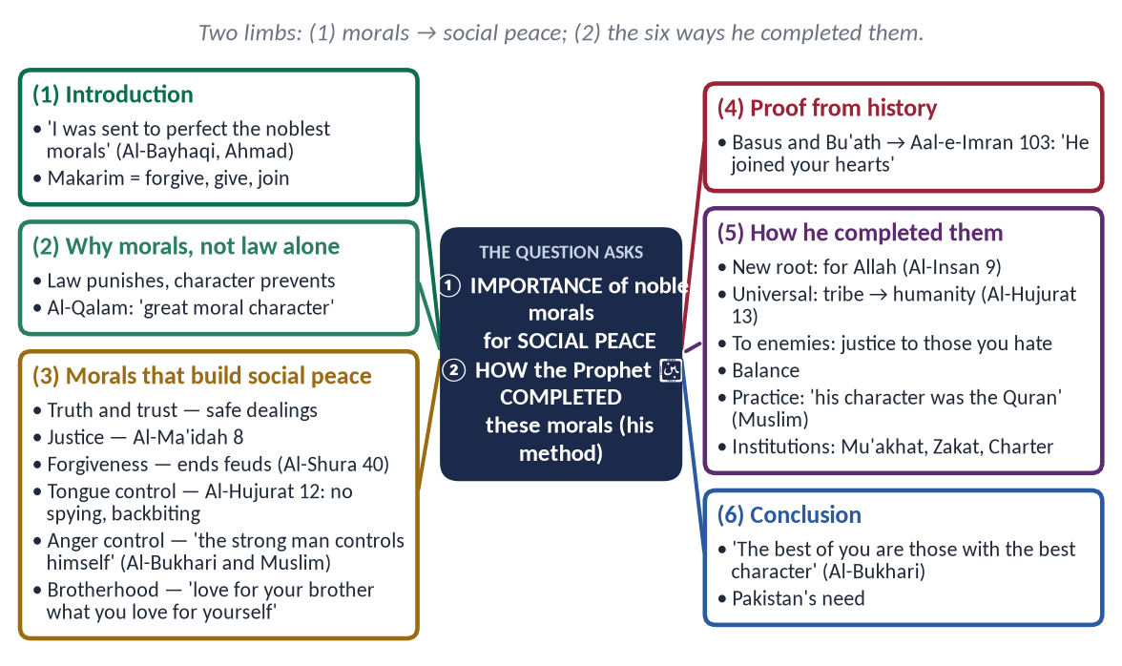
Figure 20 · The answer map: every branch is one numbered heading of the model answer below.

Decoding the question
- Limb 1 — 'importance … in establishing social peace': show how each noble moral produces peace in society.
- Limb 2 — 'how did the Messenger complete these morals': this refers to the hadith 'I was sent to perfect noble morals'. Show his method of completing them — not just a list of his virtues.
- 'In this background' links the two: his completion of morals is why his society became peaceful.

The model answer

(1) Introduction
✦ HADITH
إِنَّمَا بُعِثْتُ لِأُتَمِّمَ مَكَارِمَ الْأَخْلَاقِ
“I was sent only to perfect the noblest morals.” (Al-Bayhaqi and Ahmad)
➜ The purpose of his mission, in his own words.

Makarim al-Akhlaq (مَكَارِمُ الْأَخْلَاق) are the noblest morals — the level above ordinary decency: to forgive one who wrongs you, give to one who refuses you and keep ties with one who cuts you off. A society can live without much wealth, but not without these morals; where they are lost, no police force can keep the peace.

(2) Why social peace needs morals, not law alone
- Law punishes crime after it happens; character prevents it.
- Law reaches the visible act; morals reach the intention — envy, hatred, greed — from which conflict begins.
- Law needs enforcers; morals make every person his own guard (taqwa).
✦ HADITH
مَا مِنْ شَيْءٍ أَثْقَلُ فِي الْمِيزَانِ مِنْ حُسْنِ الْخُلُقِ
“Nothing is heavier in the Scale than good character.” (Abu Dawud and Al-Tirmidhi)
➜ Islam gives character the highest weight.

(3) The importance of noble morals in establishing social peace

(i) Truthfulness and trustworthiness — safe dealings
Trust in markets, courts and offices removes the fraud and suspicion from which disputes arise. The Prophet ﷺ was Al-Sadiq, Al-Amin even to his enemies.

(ii) Justice — no grievance, no revenge
✦ QURAN
﴿… وَلَا يَجۡرِمَنَّكُمۡ شَنَـَٔانُ قَوۡمٍ عَلَىٰٓ أَلَّا تَعۡدِلُواْۚ ٱعۡدِلُواْ هُوَ أَقۡرَبُ لِلتَّقۡوَىٰۖ …﴾
“Do not let the hatred of a people lead you to be unjust. Be just; that is nearer to righteousness.” (Al-Ma'idah, Quran)
➜ Do not let hatred of a people lead you to injustice — be just; that is nearer to taqwa.

(iii) Forgiveness — ending the cycle of revenge
✦ QURAN
﴿وَجَزَـٰٓؤُاْ سَيِّئَةٖ سَيِّئَةٞ مِّثۡلُهَاۖ فَمَنۡ عَفَا وَأَصۡلَحَ فَأَجۡرُهُۥ عَلَى ٱللَّهِۚ إِنَّهُۥ لَا يُحِبُّ ٱلظَّـٰلِمِينَ﴾
“And the retribution for an evil act is an evil one like it, but whoever pardons and makes reconciliation - his reward is [due] from Allah. Indeed, He does not like wrongdoers.” (Ash-Shura, Quran)
➜ The recompense of evil is its like, but whoever pardons and makes peace, his reward is with Allah.

(iv) Control of the tongue — no slander, suspicion or rumour
✦ QURAN
﴿… ٱجۡتَنِبُواْ كَثِيرٗا مِّنَ ٱلظَّنِّ إِنَّ بَعۡضَ ٱلظَّنِّ إِثۡمٞۖ وَلَا تَجَسَّسُواْ وَلَا يَغۡتَب بَّعۡضُكُم بَعۡضًاۚ …﴾
“Avoid much suspicion; indeed, some suspicion is sin. And do not spy, and do not backbite one another.” (Al-Hujurat, Quran)
➜ Avoid suspicion; do not spy or backbite — the Quran removes the everyday causes of quarrel.

(v) Control of anger — no violence
✦ HADITH
لَيْسَ الشَّدِيدُ بِالصُّرَعَةِ، إِنَّمَا الشَّدِيدُ الَّذِي يَمْلِكُ نَفْسَهُ عِنْدَ الْغَضَبِ
“The strong man is not the wrestler; the strong man controls himself when angry.” (Al-Bukhari and Muslim)
➜ Most social violence begins in one moment of anger.

(vi) Brotherhood and empathy — no class hatred
✦ HADITH
لَا يُؤْمِنُ أَحَدُكُمْ حَتَّى يُحِبَّ لِأَخِيهِ مَا يُحِبُّ لِنَفْسِهِ
“None of you truly believes until he loves for his brother what he loves for himself.” (Al-Bukhari and Muslim)
➜ The golden rule of social peace.

(vii) Peace-making as a virtue
✦ HADITH
أَلَا أُخْبِرُكُمْ بِأَفْضَلَ مِنْ دَرَجَةِ الصِّيَامِ وَالصَّلَاةِ وَالصَّدَقَةِ؟ ... صَلَاحُ ذَاتِ الْبَيْنِ
“Shall I not tell you of something better than fasting, prayer and charity? … Reconciling between people.” (Abu Dawud and Al-Tirmidhi)
➜ Making peace is ranked above voluntary worship.

(viii) The proof from history
Pre-Islamic Arabia lived in blood feuds — the war of Basus lasted about forty years; Bu'ath (617) had just exhausted Yathrib. Within a generation the same people were brothers:
✦ QURAN
﴿وَٱعۡتَصِمُواْ بِحَبۡلِ ٱللَّهِ جَمِيعٗا وَلَا تَفَرَّقُواْۚ وَٱذۡكُرُواْ نِعۡمَتَ ٱللَّهِ عَلَيۡكُمۡ إِذۡ كُنتُمۡ أَعۡدَآءٗ فَأَلَّفَ بَيۡنَ قُلُوبِكُمۡ فَأَصۡبَحۡتُم بِنِعۡمَتِهِۦٓ إِخۡوَٰنٗا …﴾
“And hold firmly to the rope of Allah all together and do not become divided. Remember Allah's favour upon you: you were enemies, and He brought your hearts together, and by His favour you became brothers.” (Aal-e-Imran, Quran)
➜ 'You were enemies and He joined your hearts, and you became brothers.'

(4) How the Messenger of Allah ﷺ completed the morals
The Arabs already valued generosity, courage, hospitality and loyalty. He did not destroy these; he completed them in six ways.

(i) He gave them a new root — Allah and the Hereafter
Arab virtue sought fame and tribal honour. He made it for Allah, answerable on the Day of Judgement:
✦ QURAN
﴿إِنَّمَا نُطۡعِمُكُمۡ لِوَجۡهِ ٱللَّهِ لَا نُرِيدُ مِنكُمۡ جَزَآءٗ وَلَا شُكُورًا﴾
“[Saying], "We feed you only for the countenance of Allah. We wish not from you reward or gratitude.” (Al-Insan, Quran)
➜ 'We feed you only for the sake of Allah; we want no reward or thanks from you.'

(ii) He universalised them — from the tribe to humanity
Tribal loyalty said, 'Help your brother, right or wrong.' He kept the words and changed the meaning: help the oppressor by stopping his oppression (Al-Bukhari).
✦ QURAN
﴿يَـٰٓأَيُّهَا ٱلنَّاسُ إِنَّا خَلَقۡنَٰكُم مِّن ذَكَرٖ وَأُنثَىٰ وَجَعَلۡنَٰكُمۡ شُعُوبٗا وَقَبَآئِلَ لِتَعَارَفُوٓاْۚ إِنَّ أَكۡرَمَكُمۡ عِندَ ٱللَّهِ أَتۡقَىٰكُمۡۚ إِنَّ ٱللَّهَ عَلِيمٌ خَبِيرٞ﴾
“O mankind, indeed We have created you from male and female and made you peoples and tribes that you may know one another. Indeed, the most noble of you in the sight of Allah is the most righteous of you. Indeed, Allah is Knowing and Acquainted.” (Al-Hujurat, Quran)
➜ The most honoured is the most righteous, not the noblest tribe.

✦ FROM THE SIRAH
لَا فَضْلَ لِعَرَبِيٍّ عَلَى عَجَمِيٍّ ... إِلَّا بِالتَّقْوَى
“No Arab has superiority over a non-Arab … except by taqwa.” (Musnad Ahmad (the Farewell Sermon))
➜ Morals made universal.

(iii) He extended them to enemies
Justice, mercy and forgiveness were owed even to enemies — Taif, the Makkah amnesty, the poisoner forgiven.

(iv) He balanced them
Courage without cruelty, generosity without waste, humility without weakness, mercy without injustice — the middle way (Al-Baqarah: 'a middle nation').

(v) He practised them first
✦ HADITH
كَانَ خُلُقُهُ الْقُرْآنَ
“His character was the Quran.” (Muslim)
➜ He lived every moral he taught — the Quran in practice.

(vi) He built them into institutions
- Mu'akhat — brotherhood made a social system.
- Zakat — generosity made a right of the poor.
- The Charter of Madinah — justice and tolerance made constitutional law.
- The Farewell Sermon — the sanctity of life, property and honour declared for all.
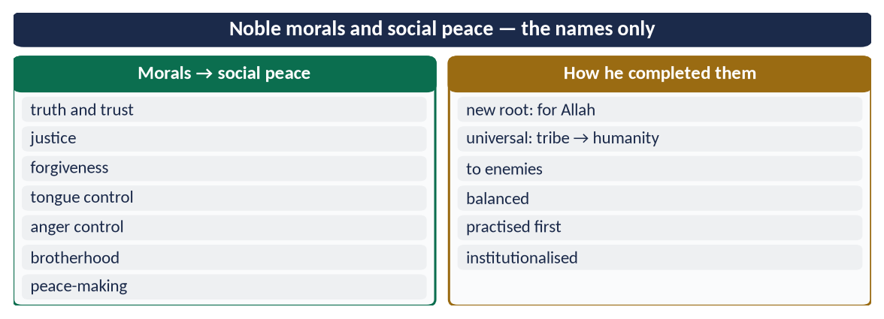
Figure 21 · At a glance — noble morals and social peace — the names only. The detail is in the sections above.

(5) Conclusion and Pakistan
✦ HADITH
إِنَّ مِنْ خِيَارِكُمْ أَحْسَنَكُمْ أَخْلَاقًا
“The best of you are those with the best character.” (Al-Bukhari)
➜ The measure of a person — and of a nation.

Noble morals are the foundation of social peace because they remove the causes of conflict that law can only punish. The Prophet ﷺ completed these morals by rooting them in faith, extending them to all humanity and to enemies, balancing them, living them, and building them into institutions — and the result was the most peaceful society Arabia had known. Pakistan's problems of intolerance, corruption and street violence are, at root, moral problems; the cure is the one he gave: character before law, and law built on character.

Why this answer scores
- Both limbs have their own headings, in the question's order.
- Limb 2 explains the method of completion (six ways) — the real demand of 'how did he complete'.
- Every moral is tied to social peace with a verse or hadith; the Pakistan conclusion is honest and relevant.

